

**Fresher Academy – FA Management**

**Requirement Specification**

**For FA Management**

Version: 0.7

**Hanoi, Jan 2018**

Approval Page

The endorsement on this document by authorized VinhNV representative indicates VinhNV and FPT’s agreement on the “FA Management Requirement Specifications” document.

|  |  |  |  |
| --- | --- | --- | --- |
| **Prepared by :** | (FPT) Trinh Hong Nhung  Business Analyst | Signature: | ____________________ |
|  |  | Date: | ____ /____ / ____ |
|  |  |  |  |
|  |  |  |  |
| **Reviewed by :** | (FPT) Hoang Tuan Anh  Business Analyst | Signature: | ____________________ |
|  |  | Date: | ____ /____ / ____ |
|  |  |  |  |
| **Supported by:** | Le Lam | Signature: | ____________________ |
|  |  | Date: | ____ /____ / ____ |
|  |  |  |  |
|  |  |  |  |
| **Approved by :** | Nguyen Van Vinh | Signature: | ____________________ |
|  |  | Date: | ____ /____ / ____ |

Revision History

|  |  |  |  |
| --- | --- | --- | --- |
| **Date** | **Version** | **Author** | **Change Description** |
| 21/06/2018 | 0.5 | NhungTH1 | Update Class Management module |
| 21/06/2018 | 0.5.5 | NhungTH1 | For internal review |
| 22/06/2018 | 0.6 | NhungTH1 | Update comments after internal review |
| 28/06/2018 | 0.6.5 | NhungTH1 | First Creation for Trainee Management module |
| 29/06/2018 | 0.6.8 | NhungTH1 | For internal review |
| 02/07/2018 | 0.7 | NhungTH1 | Update internal review  Release to customer |

**Table of Contents**

1. Introduction 9

1.1 Purpose 9

1.2 Overview 9

1.3 Intended Audience and Reading Suggestions 10

1.4 Abbreviations 10

1.5 References 11

2. High Level Requirements 12

2.1 Entity Relationship Diagram 12

2.2 Workflow 14

2.2.1 Class Management 14

2.2.2 Candidate Management 16

2.2.3 Trainee Management 16

2.3 State Transition Diagram 17

2.3.1 Class Management 17

2.3.2 Candidate Management 19

2.3.3 Trainee Management 19

2.4 Use Case Diagram 19

2.4.1 Class Management 20

2.4.2 Candidate Management 22

2.4.3 Trainee Management 23

2.4.4 Trainer Management 24

2.4.5 Report Management 25

2.5 Permission Matrix 26

3. Use Case Specifications 28

3.1 General 29

3.1.1 UC1: Log in 29

3.1.2 UC 2: Logout 31

3.2 Class Management 32

3.2.1 UC3: Create a new Class 32

3.2.2 UC4: Update an existing Class 35

3.2.3 UC5: View an existing Class 38

3.2.4 UC6: Search Class 39

3.2.5 UC7: Cancel Class 40

3.2.6 UC 8: Import Trainee to Class 42

3.2.7 UC 9: Add Trainee to Class 46

3.2.8 UC 10: Remove Trainee from Class 49

3.2.9 UC 11: Submit an existing Class 51

3.2.10 UC 12: Approve a submitted Class 53

3.2.11 UC 13: Reject a submitted Class 55

3.2.12 UC 14: Accept an approved Class 58

3.2.13 UC 15: Decline an approved Class 59

3.2.14 UC 16: Start an accepted Class 62

3.2.15 UC 17: Finish an in-progress Class 64

3.2.16 UC 18: Close a finished Class 66

3.2.17 UC 19: Request for More Information 68

3.2.18 UC 20: Update Status in Class of Trainee in a Class 71

3.2.19 UC 21: Update Attendance Status of Trainee(s) in a Class 73

3.2.20 UC 22: Update Topic Mark of Trainee(s) in a Class 76

3.2.21 UC 23: Update Reward and Penalty of Trainee(s) in a Class 80

3.2.22 UC 24: Update Allocation of Trainee(s) in a Class 83

3.3 Candidate Management 86

3.3.1 UC 25: Create a new Candidate Profile 86

3.3.2 UC 26: Update an existing Candidate 88

3.3.3 UC 27: Delete an existing Candidate 92

3.3.4 UC 28: View an existing Candidate 94

3.3.5 UC 29: Transfer Candidate 95

3.4 Trainee Management 97

3.4.1 UC 30: Update Trainee Profile 97

3.4.2 UC 31: View Trainee Profile 100

3.4.3 UC 32: Delete Trainee Profile 101

3.4.4 UC 33: Calculate Disciplinary Point 103

3.4.5 UC 34: Calculate Committed Working Duration 104

3.4.6 UC 35: Calculate Allowance 105

3.5 Common Business Rules 106

4. Mockups Screen 107

4.1 General 107

4.1.1 Log in 107

4.1.2 Landing Page - TBU 109

4.2 Class Management 111

4.2.1 Class listing 111

4.2.2 Information Tab – create & edit mode 115

4.2.3 Information Tab – view mode 118

4.2.4 UC 9: Add Trainee to Class 132

4.2.5 UC 10: Remove Trainee from Class 135

4.2.6 Trainee Tab – view mode 138

4.2.7 Trainee Tab – Import Trainee 145

4.2.8 Trainee Tab – Add Trainee 147

4.2.9 Trainee Tab – Update Status in Class of Trainee in a Class 150

4.2.10 Trainee Tab – Update Attendance Status of Trainee(s) in a Class 151

4.2.11 Trainee Tab – Update Topic Mark of Trainee(s) in a Class 156

4.2.12 Trainee Tab – Update Reward & Penalty of Trainee(s) in a Class 158

4.2.13 Trainee Tab – Update Allocation of Trainee(s) in a Class 160

4.3 Candidate Management 162

4.3.1 Candidate Listing 162

4.3.2 Candidate Profile – Create mode 166

4.3.3 Candidate Profile – View Candidate Information 168

4.3.4 Candidate Profile – Update Candidate Information 170

4.3.5 Candidate Profile – View result 176

4.3.6 Candidate Profile – Update Result 177

4.4 Trainee Management 180

4.4.1 Trainee Listing 180

4.4.2 Trainee Profile – View Trainee Information 184

4.4.3 Trainee Profile – Update Trainee Information 185

4.4.4 Trainee Profile – Update Training Result 191

4.4.5 Trainee Profile – View Training Result 194

4.4.6 Trainee Profile – Training Result – Class Listing 196

4.4.7 Trainee Profile – Training Result – Milestone Configuration 197

4.4.8 Trainee Profile – Training Result – Attendance Status 201

4.4.9 Trainee Profile – Training Result – Topic Mark 206

4.4.10 Trainee Profile – Training Result – Reward & Penalty 208

4.4.11 Trainee Profile – Training Result – GPA 210

4.4.12 Trainee Profile – Training Result – Commitment 212

4.4.13 Trainee Profile – Training Result – Allowance 214

4.4.14 Trainee Profile – Training Result – Allocation 216

5. Other Requirements 217

6. Integration 217

7. Data Migration 0

7.1 Migration Scope 0

7.2 Data Mapping 0

8. Appendices 0

8.1 Messages List 0

8.2 Email Templates 3

8.2.1 ET 1: Sending email to Class Admin for assignment 3

8.2.2 ET 2: Sending email to Class Admin for change 3

8.2.3 ET 3: Sending email to Master Trainer and Trainer for class assignment 4

8.2.4 ET 4: Sending email to Class Admin, Master Trainer, Trainer for cancelled Class 4

8.2.5 ET 5: Sending email to Delivery Manager for approval 4

8.2.6 ET 6: Sending email to FA Manager after a Class is approved by Delivery Manager 5

8.2.7 ET 7: Sending email to Class Admin, Master Trainer, Trainer after a class is rejected by Delivery Manager 5

8.2.8 ET 8: Sending email to Delivery Manager, Class Admin, Master Trainer, Trainer after a class is accepted by FA Manager 5

8.2.9 ET 9: Sending email to Delivery Manager, Class Admin, Master Trainer, Trainer after a class is declined by FA Manager 6

8.2.10 ET 10: Sending email to Delivery Manager, Master Trainer, Trainer, Trainee after a class is started by Class Admin 6

8.2.11 ET 11: Sending email to Delivery Manager after a Class is finished. 6

8.2.12 ET 12: Sending email to FA Manager after a Class is closed. 7

8.2.13 ET 13: Sending email to Class Admin after a class is requested by Delivery Manager 7

8.2.14 ET 14: Sending email to Candidate and Campus to inform after Candidate is transferred to Campus 7

8.2.15 ET 15: Sending email to Candidate and FA to inform after Candidate is transferred to FA 8

8.2.16 ET 16: Sending email to Candidate and Internship to inform after Candidate is transferred to Internship 8

# Introduction

## Purpose

The Functional Requirements Specification will:

* Define the scope of business objectives, business functions, and organizational units covered,
* Identify the business processes that the solution must facilitate,
* Facilitate a common understanding of what the functional requirements are for all parties involved,
* Establish a basis for defining the acceptance tests for the solution to confirm that what is delivered meets requirements.

The purpose of the document is to collect and analyse all assorted ideas that have come up to define the system, its requirements with respect to consumers. Also, we shall predict and sort out how we hope this product will be used in order to gain a better understanding of the project, outline concepts that may be developed later, and document ideas that are being considered, but may be discarded as the product develops.

## Overview

This system is used for recruitment activities at Fresher Academy such as:

* Recruit fresher
* Manage training activities
* Report to higher manager

Actors and Roles:

|  |  |
| --- | --- |
| **Actor** | **Roles** |
| FA. Manager | * The Manager of Fresher Academy * Having responsibility to manage all activities at Fresher Academy |
| FA. Rec | * Recruitment Department of Fresher Academy * Having these following responsibilities: * Recruit candidates * Implement entry test and interview * Receive candidates |
| Delivery Manager | * Manager of Delivery Department at Fresher Academy * Having these following responsibilities: * Create Class * Assign Class Admin * Manage Classes |
| Class Admin | * Class Admin at a Class * Having these following responsibilities: * Manage class * Manage trainee * Manage trainees’ marks * Assign Trainer to Class |
| Trainer | Evaluate trainees’ training results |

Figure 1: Actors and Roles in system

Entities managed out-side system:

_Topic

_University

_Faculty

## Intended Audience and Reading Suggestions

This document is intended for:

* Development team: Responsible to develop detailed design, implement and perform unit test, integration test and system test for the migrated application
* Data Migration team: Responsible to create data migration scripts, and perform data migration for the application.
* Documentation Team: Responsible to write User Guide for the application.
* UAT team: Responsible to conduct user acceptance test sessions with end users.

## Abbreviations

|  |  |
| --- | --- |
| **Acronym** | **Reference** |
| FA | Fresher Academy |
| UC | Use Case |
| BR | Business Rule |
| CBR | Common Business Rules |
| MSG | Message |
| Class | Class / Course |

## References

N/A

# High Level Requirements

This section describes the general overview of the system functions or business processes which are depicted in different diagrams. It shows the types of users, their granted permissions to perform specific system functions and the sequence required to complete a business workflow (if any). As the section name implies, it is high-level which mean not detailed enough. For detailed requirement specification, please see section below.

## Entity Relationship Diagram

This section graphically illustrates an information system’s entities and the relationships between those entities.

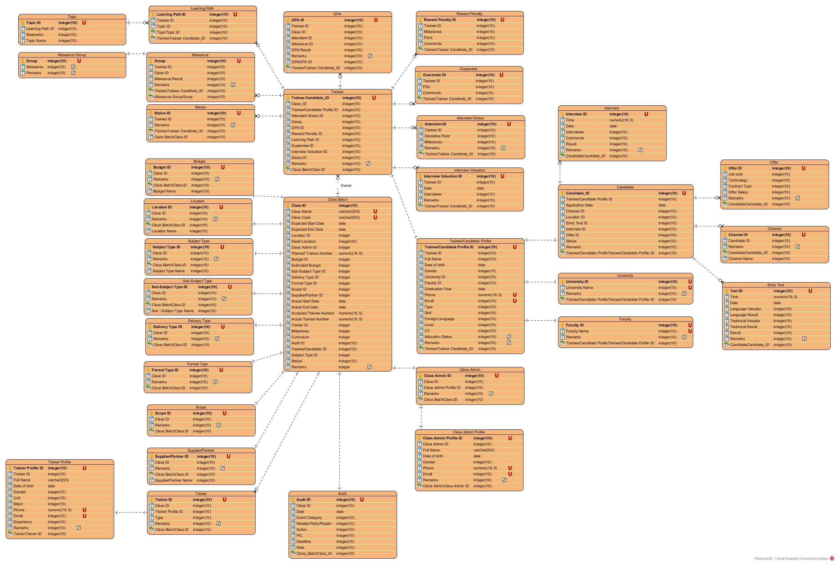

Figure 2: Entity Relationship Diagram of Fresher Academy

## Workflow

### Class Management



Figure 3: Workflow for Class Management Module

### Candidate Management

N/A.

### Trainee Management

N/A.

## State Transition Diagram

### Class Management



Figure 4: State Transition Diagram for Class Management Module

### Candidate Management

N/A.

### Trainee Management

N/A.

## Use Case Diagram

The use case diagram here shows the specific goal and objective or how the user interacts with the system. The eclipse in the system boundary represents the system use case/functions while the stickman represents the actor/user of the system. The line connecting the actor and the use case shows that the actor can perform that function in the system to achieve a goal.

### Class Management



Figure 5: Use Case Diagram for Class Management Module

|  |  |  |
| --- | --- | --- |
| **#** | **UC Name** | **Description** |
| 1 | Create Class | This function allows Delivery Manager to create a new Class. |
| 2 | Update Class | This function allows the user to update information such as Budget, Audit,… of an existing Class. |
| 3 | View Class | This function allows the user to view an existing Class Information. |
| 4 | Search Class | This function allows the user to search Class. |
| 5 | Cancel Class | This function allows Delivery Manager to cancel a Class. |
| 6 | Import Trainee to Class. | This function allows Delivery Manager to import Trainee(s) to Class from an excel file. |
| 7 | Add Trainee to Class | This function allows Delivery Manager to add Trainee(s) to Class. |
| 8 | Remove Trainee from Class | This function allows Delivery Manager to remove Trainee(s) from Class. |
| 9 | Submit Class | This function allows Class Admin to submit an existing Class to Delivery Manager. |
| 10 | Approve | This function allows Delivery Manager to approve an submitted Class. |
| 11 | Reject | This function allows Delivery Manager to reject a submitted Class. |
| 12 | Start Class | This function allows Class Admin to start an accepted Class. |
| 13 | Finish Class | This function allows Class Admin to finish a Class ready to close. |
| 14 | Close Class | This function allows Delivery Manager to close a finished Class. |
| 15 | Request for more information | This function allows Delivery Manager to disagree to close a Class and request for more information. |
| 16 | Accept | This function allows FA Manager to accept to open an approved Class. |
| 17 | Decline | This function allows FA Manager to decline to open an approved Class. |

### Candidate Management



Figure 6: Use Case Diagram for Candidate Management Module

|  |  |  |
| --- | --- | --- |
| **#** | **UC Name** | **Description** |
| 1 | Create Candidate Profile | This function allows FA Recruitment to create a new Candidate Profile. |
| 2 | Update Candidate Profile | This function allows FA Recruitment to update an existing Candidate Profile. |
| 3 | Delete Candidate Profile | This function allows FA Recruitment to delete an existing Candidate Profile. |
| 4 | View Candidate Profile | This function allows FA Recruitment to view an existing Candidate Profile. |
| 5 | Transfer Candidate | This function allows FA Recruitment to transfer a candidate to Internship or FA or Campus Link. |

### Trainee Management



Figure 6: Use Case Diagram for Trainee Management Module

|  |  |  |
| --- | --- | --- |
| **#** | **UC Name** | **Description** |
| 1 | Update Trainee Profile | This function allows Delivery Manager and Class Admin to update an existing Trainee Profile in terms of Trainee Personal Information, Trainee Milestone Configuration, Trainee Attendance Status,… |
| 2 | View Trainee Profile | This function allows Delivery Manager and Class Admin to view an existing Trainee Profile. |
| 3 | Delete Trainee Profile | This function allows Delivery Manager to delete an existing Trainee Profile. |
| 4 | Calculate Disciplinary Point | System calculates Disciplinary Point of a Trainee in a Class. |
| 5 | Calculate Committed Working Duration | System calculates Committed Working Duration of a Trainee in a Class. |
| 6 | Calculate Allowance | System calculates Allowance of a Trainee in a Class. |

### Trainer Management



Figure 6: Use Case Diagram for Trainer Management Module

|  |  |  |
| --- | --- | --- |
| **#** | **UC Name** | **Description** |
| 1 | Create Trainer Profile | This function allows Delivery Manager to create a new Trainer Profile. |
| 2 | Update Trainer Profile | This function allows Delivery Manager to update an existing Trainer Profile. |
| 3 | View Trainer Profile | This function allows Delivery Manager to view an existing Trainer Profile. |
| 4 | Delete Trainer Profile | This function allows Delivery Manager to delete an existing Trainer Profile. |

### Report Management



Figure 6: Use Case Diagram for Report Management Module

|  |  |  |
| --- | --- | --- |
| **#** | **UC Name** | **Description** |
| 1 | Generate Report | This function allows user to generate report basing on the selected criteria. |
| 2 | View Report | This function allows user to view generated report basing on the selected criteria. |
| 3 | Export Report | This function allows user to export generated report basing on the selected criteria to excel file. |

## Permission Matrix

Permission Matrix mapping functions and user roles for FA Management application is described as below:

Remarks:

|  |  |
| --- | --- |
| X | User has permission to do this function with all records. |
| X* | User has permission to do this function with records pending for him/her or belonging to him/her only. |

|  |  |  |  |  |  |  |
| --- | --- | --- | --- | --- | --- | --- |
|  | **FA.**  **Manager** | **Delivery Manager** | **Class Admin** | **FA. Rec** | **Trainer** | **System Admin** |
| **Module1: Class Management** | | | | | | |
| Create Class | X | X |  |  |  | X |
| Update Class | X | X |  |  |  | X |
| View Class | X | X | X | X | X | X |
| Search Class | X | X | X | X | X | X |
| Cancel Class | X | X |  |  |  | X |
| Import Trainee to Class | X | X |  |  |  | X |
| Add Trainee to Class | X | X |  |  |  | X |
| Remove Trainee from Class | X | X |  |  |  | X |
| Submit Class | X | X | X* |  |  | X |
| Approve Class | X | X |  |  |  | X |
| Reject Class | X | X |  |  |  | X |
| Accept Class | X |  |  |  |  | X |
| Decline Class | X |  |  |  |  | X |
| Start Class | X | X | X |  |  | X |
| Finish Class | X | X | X* |  |  | X |
| Close Class | X | X |  |  |  | X |
| Request for more information | X | X |  |  |  | X |
| **Module 2: Candidate Management** | | | | | | |
| Create Candidate Profile | X |  |  | X |  | X |
| Update Candidate | X |  |  | X |  | X |
| View Candidate | X | X | X* | X | X* | X |
| Delete Candidate | X |  |  | X |  | X |
| Transfer Candidate | X |  |  | X |  | X |
| **Module 3: Trainee Management** | | | | | | |
| Update Trainee Profile | X | X | X* |  |  | X |
| View Trainee Profile | X | X | X* |  | X* | X |
| Delete Trainee Profile | X | X |  |  |  | X |
| **Module 4: Trainer Management** | | | | | | |
| Create Trainer Profile | X |  |  |  |  | X |
| Update Trainer Profile | X |  | X |  | X* | X |
| View Trainer Profile | X | X | X | X | X | X |
| Delete Trainer Profile | X |  |  |  |  | X |
| **Module 5: Report management** | | | | | | |
| Create report | X | X | X | X | X | X |
| View report | X | X | X | X | X | X |
| Export report | X | X | X | X | X | X |

# Use Case Specifications

This section covers the system’s functional requirements which details what the system must do in terms of input, behavior and the expected output. It elicits the interaction between the actor(s) and the system, the system’s behavior and the results of their interactions.

## General

### ­­UC1: Log in

|  |  |
| --- | --- |
| **Objective:** | This function allows user to login to system. |
| **Actor:** | All authenticated users. |
| **Trigger:** | User selects to login on Login screen. |
| **Pre-condition:** | User is not yet logged in to system. |
| **Post-condition:** | User is logged in to system successfully. |

**Activities Flows**



**Business Rules**

|  |  |  |
| --- | --- | --- |
| **Step** | **BR Code** | **Description** |
| (2) | BR 1 | **Validation Rules:**  System will check the following rules:   * If the value of [User Name] field or [Password] field does not match with any user data in the database, system will display MSG 1. * If the value of [User Name] field is blank, system will display MSG 2. * If the value of [Password] field is blank, system will display MSG 3. |
| (3) | BR 2 | **Screen Displaying Rules:**  System will display corresponding screen as Screen 2: Landing Page. |

### UC 2: Logout

|  |  |
| --- | --- |
| **Objective:** | This function allows user to logout from system. |
| **Actor:** | All authenticated users. |
| **Trigger:** | User selects to logout. |
| **Pre-condition:** | User is logged in successfully. |
| **Post-condition:** | User is logged out from system successfully. |

**Activities Flows**



**Business Rules**

|  |  |  |
| --- | --- | --- |
| **Step** | **BR Code** | **Description** |
| (2) | BR 3 | **Screen Displaying Rules:**  System will display corresponding screen as Screen 1: Login screen. |

## Class Management

### UC3: Create a new Class

|  |  |
| --- | --- |
| **Objective:** | This use case allows user to create a new Class. |
| **Actor:** | * System Admin. * FA Manager. * Delivery Manager. |
| **Trigger:** | User selects to create a new Class. |
| **Pre-condition:** | User is logged in successfully as actors above. |
| **Post-condition:** | A new Class is created successfully. |

**Activities Flow**



**Business Rules**

|  |  |  |
| --- | --- | --- |
| **Step** | **BR Code** | **Description** |
| (2) | BR 4 | **Screen Displaying Rules:**  System will display corresponding screen as Screen 4: Class in create & edit mode. |
| (4) | BR 5 | **Validation Rules:**  System will validate all the rules as CBR 1. |
| (5) | BR 6 | **Pop-up Displaying Rules:**  System will display confirmation pop-up as the following:  Snapshot |
| (7) | BR 7 | **Creating Rules:**  System will:   * Set the value of [Status] field as “Draft”. * Set the value of field [Created date] as <<Current date>>. * Append a new line in [History] field as the following:   *<<Current date time>> - “Created by” <<Current user’s name>>*   * Save the information. * Display MSG 23. * Refresh current screen. * Send email to assigned Class Admin as ET 1: Sending email to Class Admin for assignment. |

### UC4: Update an existing Class

|  |  |
| --- | --- |
| **Objective:** | This use case allows user to update Class. |
| **Actor:** | * System Admin. * FA Manager. * Delivery Manager. * Class Admin. |
| **Trigger:** | User selects to update Class. |
| **Pre-condition:** | * User is logged in successfully as actor above. * The value of [Status] field is equal to “Draft” if user updates General table, Detail table, Budget table. * The value of [Status] filed is equal to “In progress” if user updates Audit table. |
| **Post-condition:** | Class is updated successfully. |

**Activities Flow**



**Business Rules**

|  |  |  |
| --- | --- | --- |
| **Step** | **BR Code** | **Description** |
| (2) | BR 8 | **Screen Displaying Rules:**  System will display corresponding screen as Screen 4: Class in create & edit mode. |
| (4) | BR 9 | **Validation Rules:**   * If user updates General table, system will validate all the rules as CBR 1. * If user updates Budget table, if the inputted value is not number, system will display MSG 6. * If user updates Audit table, if the inputted value is wrong format, system will display MSG 5. |
| (5) | BR 10 | **Pop-up Displaying Rules:**  System will display confirmation pop-up as the following:  Snapshot |
| (7) | BR 11 | **Updating Rules:**  System will:   * Update all calculated fields. * Append a new line in the [History] field as the following:   *<<Current date time>> - “Updated by” <<Current user’s name>>*   * Save the information. * Display MSG 22. * Back to view mode. * Send email to assigned Class Admin as ET 2: Sending email to Class Admin for change. * Send email to assigned Master Trainer and Trainer as ET 3: Sending email to Master Trainer and Trainer for class assignment. |

### UC5: View an existing Class

|  |  |
| --- | --- |
| **Objective:** | This use case allows user to view an existing Class. |
| **Actor:** | All authenticated users. |
| **Trigger:** | User selects to view a Class. |
| **Pre-condition:** | User is logged in successfully as actor above. |
| **Post-condition:** | Class is displayed successfully. |

**Activities Flow**



**Business Rules**

|  |  |  |
| --- | --- | --- |
| **Step** | **BR Code** | **Description** |
| (2) | BR 12 | **Screen Displaying Rules:**  System will display corresponding screen as Screen 5: Class in view mode. |

### UC6: Search Class

|  |  |
| --- | --- |
| **Objective:** | This use case allows user to search existing Classes. |
| **Actor:** | All authenticated users. |
| **Trigger:** | User selects to search Classes. |
| **Pre-condition:** | User is logged in successfully as actor above. |
| **Post-condition:** | Class list is displayed successfully. |

**Activities Flow**



**Business Rules**

|  |  |  |
| --- | --- | --- |
| **Step** | **BR Code** | **Description** |
| (4) | BR 13 | **Searching Rules:**  System will retrieve all classes as the following conditions:   * If user does not enter any criteria, system will display all Classes on the search result view. * If user enter any criteria, system will display all satisfied Classes depending on criteria inputted as the following process:   + If the value of [Location] field is not blank, system will filter all Classes that have the value of [Location] field equal to inputted value. Then system will continue search process by searching by “Status” criteria.   + If the value of [Location] field is blank, system will continue search process by searching by “Status” criteria as below:     - If the value of [Status] field is not blank, system will filter all Classes that have the value of [Status] field equal to inputted value. Then system will continue search process by searching by “From Date” criteria and “To Date” criteria.     - If the value of [Status] field is blank, system will continue search process by searching by “From Date” criteria and “To Date” criteria as below:       * If value of [From Date] field and [To Date] field are not blank, system will filter all classes which have the value of [Actual Start Date] field > inputted [From Date] and the value of [Actual End Date] field < inputted [To Date]. Then system will continue search process by searching by “Class Name” criteria.       * If the value of [From Date] field and [To Date] field are blank, system will:         + Filter all classes which have the value of [Class Name] field includes the value of inputted [Class Name] field.         + Example: If user inputs “Java” to [Class Name] field for search in the Search box, system will filter all classes which include the text “Java” in name such as “Java class 1”.   **Returning Result Rules:**  System will:   * In case there is no item matches the search criteria, system will show MSG 8. * Otherwise, system will display all returned Classes on the result view. |

### UC7: Cancel Class

|  |  |
| --- | --- |
| **Objective:** | This use case allows user to cancel an existing Class. |
| **Actor:** | * System Admin. * FA Manager. * Delivery Manager. |
| **Trigger:** | User selects to cancel a Class. |
| **Pre-condition:** | * User is logged in successfully as actor above. * The value of [Status] is equal to “Draft” or “Submitted”. |
| **Post-condition:** | Class is cancelled successfully. |

**Activities Flow**



**Business Rules**

|  |  |  |
| --- | --- | --- |
| **Step** | **BR Code** | **Description** |
| (2) | BR 14 | **Pop-up Displaying Rules:**  The system will display confirmation pop-up as the following:  C:\Users\MyPC\AppData\Local\Temp\flaC647.tmp\Snapshot.png |
| (4) | BR 15 | **Cancellation Rules:**  System will:   * Update the value of [Status] field as “Cancelled”. * Append a new line in the [History] field as the following:   *<<Current date time>> - “Cancelled by” <<Current user’s name>>*   * Save the information and back to view listing screen. * Send email to Class Admin, Master Trainer and Trainer as ET 4: Sending email to Class Admin, Master Trainer, Trainer for cancelled Class.   **Deletion Rules:**  If <<Current date>> - [Created date] >= 1. System will delete the class. |

### UC 8: Import Trainee to Class

|  |  |
| --- | --- |
| **Objective:** | This use case allows user to import Trainee from excel file. |
| **Actor:** | * System Admin. * FA Manager. * Delivery Manager. |
| **Trigger:** | User selects to import Trainee. |
| **Pre-condition:** | * User is logged in successfully as actors above. * The value of [Status] field of class is equal to “Draft”. |
| **Post-condition:** | Trainee List is imported successfully. |

**Activities Flow**



**Business Rules**

|  |  |  |
| --- | --- | --- |
| **Step** | **BR Code** | **Description** |
| (2) | BR 16 | **Screen Displaying Rules:**  The system will display screen as Screen 7: Screen for Delivery Manager to import Trainee to Class. |
| (4) | BR 17 | **Validating Rules:**  If the selected file is not *.xls or *.xlsx, system will display MSG 25. |
| (5) | BR 18 | **Checking Rules:**  System will compare the combination of [Name], [DOB], [Phone] and [Email] in each row in excel file with the corresponding [Name], [Date of Birth], [Phone] and [Email] in database:   * If no value matches, system will:   + Create a new trainee profile as below:     - The value of [Empl ID] in excel file is equal to [Empl ID] in the table.     - The value of [Name] in excel file is equal to [Name] in the table.     - The value of [DOB] in excel file is equal to [DOB] in the table.     - The value of [Gender] in excel file is equal to [Gender] in the table.     - The value of [University] in excel file is equal to [University] in the table     - The value of [Faculty] in excel file is equal to [Faculty] in the table.     - The value of [Phone] in excel file is equal to [Phone] in the table.     - The value of [Email] in excel file is equal to [Email] in the table.   + Set the value of [Status] is equal to “Enrolled”.   + Save trainee profile.   + Add trainee to class as Importing Rules below. * If all values match, system will compare the combination of [Name], [DOB], [Phone] and [Email] in that row in excel file with the corresponding [Name], [DOB], [Phone] and [Email] in the Trainee List in Trainee tab of current Class:   + If all values match, system will pass trainee in this row and process the next trainee in the next row in excel file.   + If no value matches, system will add trainee to class as Importing Rules below.   **Importing Rules:**   * System will: * Import the data satisfied above comparison in excel file equal to each column of table of trainee list with each row, start from 2nd row:   + The value of [#] in table is updated basing on the number of trainee.   + The value of B column in excel file is equal to [Empl ID] in the table.   + The value of E column in excel file is equal to [Name] in the table.   + The value of J column in excel file is equal to [DOB] in the table.   + The value of K column in excel file is equal to [Gender] in the table.   + The value of H column in excel file is equal to [University] in the table   + The value of I column in excel file is equal to [Faculty] in the table.   + The value of M column in excel file is equal to [Phone] in the table.   + The value of L column in excel file is equal to [Email] in the table. * Update information of current trainee as the following:   + Set the value of [Status] field is equal to “Enrolled”.   + Set the value of [Allocation Status] is equal to “Not Allocated”.   + Add a new tab in Class Listing in Training Result tab in current Trainee Profile with:     - Tab name is equal to the value of [Class Name] field of the class which current trainee is assigned to.     - The value of [Status in Class] field for current Class is equal to “Enrolled”. * Save all changes. * Back to view listing screen. * Sample excel file to import: |

### UC 9: Add Trainee to Class

|  |  |
| --- | --- |
| **Objective:** | This use case allows user to add Trainee(s) to Class. |
| **Actor:** | * System Admin. * FA Manager. * Delivery Manager. |
| **Trigger:** | User selects to add Trainee(s) to Class. |
| **Pre-condition:** | * User is logged in successfully as actor above. * The value of [Status] field of class is equal to “Draft”. * The value of [Status] field of trainee is equal to “Waiting for Class” or “Waiting for Allocation” or “Deferred” or “Drop-out”. * The value of [Status in Class] field of trainee is not equal to “In-progress” or “Enrolled”. * The value of [Allocation Status] field of trainee is not equal to “Allocated”. |
| **Post-condition:** | Trainees(s) is added to Class successfully. |

**Activities Flow**



**Business Rules**

|  |  |  |
| --- | --- | --- |
| **Step** | **BR Code** | **Description** |
| (2) | BR 19 | **Screen Displaying Rules:**  The system will display pop-up as Screen 8: Pop-up for Delivery Manager to add Trainee to Class. |
| (4) | BR 20 | **Validating Rules:**  System will validate the inputted criteria as the following rules:   * If the inputted value of any field is wrong format, system will display MSG 5. * In case user inputs [Phone] field, if the value of inputted field does not start by “0” number, system will display MSG 9. * In case user inputs [Phone] field, if the value of inputted field is under 10 characters or over 14 characters, system will display MSG 24.   **Trainee List Displaying Rules:**  After all the Validating Rules are passed, system will filter all the trainees satisfied the search criteria and having the value of [Status] is “Waiting for Class” or “Waiting for Allocation” or “Deferred” or “Drop-out” and then display to the table below. |
| (6) | BR 21 | **Saving Rules:**   * System will add trainee to the Trainee List table as following rules: * [#] column: updated basing on the number of trainee . * [Empl ID] column: As value of [Empl ID] field in “Trainee Profile”. * [Name] column: As value of [Name] field in “Trainee Profile”. * [DOB] column: As value of [Date of birth] field in “Trainee Profile”. * [University] column: As value of [University] field in “Trainee Profile”. * [Faculty] column: As value of [Faculty] field in “Trainee Profile”. * [Gender] column: As value of [Gender] field in “Trainee Profile”. * [Phone] column: As value of [Phone] field in “Trainee Profile”. * [Email] column: As value of [Email] field in “Trainee Profile”. * Update the information of current trainee as the following:   + Update the value of [Status] field is equal to “Enrolled”.   + Update the value of [Allocation Status] is equal to “Not Allocated”.   + Add a new tab in Class Listing in Training Result tab in current Trainee Profile with:     - Tab name is equal to the value of [Class Name] field of the class which current trainee is added to.     - The value of [Status in Class] field for current Class is equal to “Enrolled”. * Save all changes. * Stay in current screen. |

### UC 10: Remove Trainee from Class

|  |  |
| --- | --- |
| **Objective:** | This use case allows user to remove a Trainee from Class. |
| **Actor:** | * System Admin. * FA Manager. * Delivery Manager. |
| **Trigger:** | User selects to remove Trainee. |
| **Pre-condition:** | * User is logged in successfully as actor above. * The value of [Status] of class is equal to “Draft”. * The value of [Status] field of trainee is equal to “Waiting for Class”. * The value of [Status in Class] field of trainee is not equal to “Active”. * The value of [Allocation Status] field of trainee is equal to “Not Allocated”. |
| **Post-condition:** | Trainee is removed successfully. |

**Activities Flow**



**Business Rules**

|  |  |  |
| --- | --- | --- |
| **Step** | **BR Code** | **Description** |
| (2) | BR 22 | **Pop-up Displaying Rules:**  System will display a confirmation Pop up as the following:  Snapshot |
| (4) | BR 23 | **Removing Rules:**  System will:   * Update information of current Class as the following:   + Remove selected row(s) from trainee list table in Trainee tab.   + Update the value of [Planned Trainee Number] field in General tab as total number of trainees existing in the trainee list table. * Update information of removed Trainee as the following:   + Update the value of [Status] field as “Waiting for Class”.   + Remove current Class in Class Listing in Training Result tab in Trainee Profile. * Save all changes. * Stay in current screen. |

### UC 11: Submit an existing Class

|  |  |
| --- | --- |
| **Objective:** | This use case allows user to submit an existing Class. |
| **Actor:** | * System Admin. * FA Manager. * Delivery Manager. * Class Admin. |
| **Trigger:** | User selects to submit Class. |
| **Pre-condition:** | * If user is Class Admin, the class must be assigned to him. * User is logged in successfully as actor above. * The value [Status] field of class is equal to “Draft”. |
| **Post-condition:** | A Class is submitted successfully. |

**Activities Flow**



**Business Rules**

|  |  |  |
| --- | --- | --- |
| **Step** | **BR Code** | **Description** |
| (2) | BR 24 | **Pop-up Displaying Rules:**  System will display confirmation pop-up as the following:  Snapshot |
| (4) | BR 25 | **Submission Rules:**  System will:   * Append a new line in the [History] field as the following:   *<<Current date time>> - “Submitted by” <<Current user’s name>>*   * Update the value of [Status] field as “Submitted”. * Save the information. * Display MSG 26. * Back to view listing screen. * Send email to Delivery Manager as ET 5: Sending email to Delivery Manager for approval. |

### UC 12: Approve a submitted Class

|  |  |
| --- | --- |
| **Objective:** | This use case allows user to approve a submitted Class. |
| **Actor:** | * System Admin. * FA Manager. * Delivery Manager. |
| **Trigger:** | User selects to approve a Class. |
| **Pre-condition:** | * User is logged in successfully as actor above. * The value of [Status] filed is equal to “Submitted”. |
| **Post-condition:** | Class is approved successfully. |

**Activities Flow**



**Business Rules**

|  |  |  |
| --- | --- | --- |
| **Step** | **BR Code** | **Description** |
| (2) | BR 26 | **Pop-up Displaying Rules:**  System will display confirmation pop-up as the following:  C:\Users\MyPC\AppData\Local\Temp\fla15FC.tmp\Snapshot.png |
| (4) | BR 27 | **Approval Rules:**  System will:   * Update the value of [Status] filed as “Planning”. * Append a new line in [History] field as following:   *<<Current date time>> - “Approved by” <<Current user>>*   * Save the information. * Display MSG 27. * Back to view listing screen. * Send email to FA Manager as ET 6: Sending email to FA Manager after a Class is approved by Delivery Manager. |

### UC 13: Reject a submitted Class

|  |  |
| --- | --- |
| **Objective:** | This use case allows user to reject a submitted Class. |
| **Actor:** | * System Admin. * FA Manager. * Delivery Manager. |
| **Trigger:** | User selects to reject Class. |
| **Pre-condition:** | * User is logged in successfully as actor above. * The value of [Status] filed is equal to “Submitted”. |
| **Post-condition:** | Class is rejected successfully. |

**Activities Flow**



**Business Rules**

|  |  |  |
| --- | --- | --- |
| **Step** | **BR Code** | **Description** |
| (2) | BR 28 | **Pop-up Displaying Rules:**  The system will display confirmation pop-up as the following:  C:\Users\MyPC\AppData\Local\Temp\fla6ABB.tmp\Snapshot.png |
| (4) | BR 29 | **Pop-up Displaying Rules:**  The system will display reason pop-up and require user to input as the following:  C:\Users\MyPC\AppData\Local\Temp\fla98A4.tmp\Snapshot.png |
| (6) | BR 30 | **Rejection Rules:**  System will:   * Update the value of [Status] field as “Rejected”. * Append a new line in the [History] field as following:   *<<Current date time>> - “Rejected by” <<Current user’s name>> - <<Remarks content>>*   * Save all changes * Back to view listing screen. * Send email to Class Admin as ET 7: Sending email to Class Admin, Master Trainer, Trainer after a class is rejected by Delivery Manager. |

### UC 14: Accept an approved Class

|  |  |
| --- | --- |
| **Objective:** | This use case allows user to accept an approved Class. |
| **Actor:** | * System Admin. * FA Manager. |
| **Trigger:** | User selects to accept to open Class. |
| **Pre-condition:** | * User is logged in successfully as actor above. * The value of [Status] field is equal to “Planning”. |
| **Post-condition:** | Class is accepted successfully. |

**Activities Flow**



**Business Rules**

|  |  |  |
| --- | --- | --- |
| **Step** | **BR Code** | **Description** |
| (2) | BR 31 | **Pop-up Displaying Rules:**  System will display confirmation pop-up as the following:  C:\Users\MyPC\AppData\Local\Temp\fla1EF1.tmp\Snapshot.png |
| (4) | BR 32 | **Accepting Rules:**  System will:   * Update the value of [Status] filed as “Planned”. * Append a new line in [History] field as following:   *<<Current date time>> - “Approved by” <<Current user>>*   * Save the information. * Display MSG 28. * Back to view listing screen. * Send email to Delivery Manager, Class Admin, Master Trainer, Trainer as ET 8: Sending email to Delivery Manager, Class Admin, Master Trainer, Trainer after a class is accepted by FA Manager. |

### UC 15: Decline an approved Class

|  |  |
| --- | --- |
| **Objective:** | This use case allows user to decline an approved Class. |
| **Actor:** | * System Admin. * FA Manager. |
| **Trigger:** | User selects to decline a Class. |
| **Pre-condition:** | * User is logged in successfully as actor above. * [Status] is equal to “Planning”. |
| **Post-condition:** | A Class is declined successfully. |

**Activities Flow**



**Business Rules**

|  |  |  |
| --- | --- | --- |
| **Step** | **BR Code** | **Description** |
| (2) | BR 33 | **Pop-up Displaying Rules:**  The system will display confirmation pop-up as the following:  C:\Users\MyPC\AppData\Local\Temp\fla2AFE.tmp\Snapshot.png |
| (4) | BR 34 | **Pop-up Displaying Rules:**  The system will display reason pop-up and require user to input as the following:  C:\Users\MyPC\AppData\Local\Temp\fla98A4.tmp\Snapshot.png |
| (6) | BR 35 | **Rejection Rules:**  System will:   * Update the value of [Status] field as “Declined”. * Append a new line in the [History] field as following:   *<<Current date time>> - “Declined by” <<Current user’s name>> - <<Remarks content>>*   * Save all changes * Back to view listing screen. * Send email to Delivery Manager, Class Admin, Master Trainer, Trainer as ET 9: Sending email to Delivery Manager, Class Admin, Master Trainer, Trainer after a class is declined by FA Manager. |

### UC 16: Start an accepted Class

|  |  |
| --- | --- |
| **Objective:** | This use case allows user to start an accepted Class. |
| **Actor:** | * System Admin. * FA Manager. * Delivery Manager. * Class Admin. |
| **Trigger:** | User selects to start a Class. |
| **Pre-condition:** | * User is logged in successfully as actor above. * [Status] is equal to “Planned”. |
| **Post-condition:** | A Class is started successfully. |

**Activities Flow**



**Business Rules**

|  |  |  |
| --- | --- | --- |
| **Step** | **BR Code** | **Description** |
| (2) | BR 36 | **Pop-up Displaying Rules:**  System will display confirmation pop-up as the following:  C:\Users\MyPC\AppData\Local\Temp\flaDD6C.tmp\Snapshot.png |
| (4) | BR 37 | **Starting Rules:**  System will:   * Update the value of [Status] filed as “In Progress”. * Append a new line in [History] field as following:   *<<Current date time>> - “Started by” <<Current user>>*   * Save the information. * Display MSG 29. * Back to view listing screen. * Send email to Delivery Manager, Master Trainer, Trainer, Trainee as ET 10: Sending email to Delivery Manager, Master Trainer, Trainer, Trainee after a class is started by Class Admin |

### UC 17: Finish an in-progress Class

|  |  |
| --- | --- |
| **Objective:** | This use case allows user to finish an in-progress Class. |
| **Actor:** | * System Admin. * FA Manager. * Delivery Manager. * Class Admin. |
| **Trigger:** | User selects to finish a Class. |
| **Pre-condition:** | * User is logged in successfully as actor above. * The value of [Status] filed is equal to “In Progress”. |
| **Post-condition:** | Class is finished successfully. |

**Activities Flow**



**Business Rules**

|  |  |  |
| --- | --- | --- |
| **Step** | **BR Code** | **Description** |
| (2) | BR 38 | **Pop-up Displaying Rules:**  System will display confirmation pop-up as the following:  C:\Users\MyPC\AppData\Local\Temp\fla6ADC.tmp\Snapshot.png |
| (4) | BR 39 | **Finishing Rules:**  System will:   * Update the value of [Status] filed as “Pending for review”. * Append a new line in [History] field as following:   *<<Current date time>> - “Finished by” <<Current user>>*   * Save the information. * Display MSG 30. * Back to view listing screen. * Send email to Delivery Manager as ET 11: Sending email to Delivery Manager after a Class is finished. |

### UC 18: Close a finished Class

|  |  |
| --- | --- |
| **Objective:** | This use case allows user to close a finished Class. |
| **Actor:** | * System Admin. * FA Manager. * Delivery Manager. |
| **Trigger:** | User selects to close a Class. |
| **Pre-condition:** | * User is logged in successfully as actor above. * The value of [Status] filed is equal to “Pending for review”. |
| **Post-condition:** | Class is closed successfully. |

**Activities Flow**



**Business Rules**

|  |  |  |
| --- | --- | --- |
| **Step** | **BR Code** | **Description** |
| (2) | BR 40 | **Pop-up Displaying Rules:**  System will display confirmation pop-up as the following:  C:\Users\MyPC\AppData\Local\Temp\flaDE51.tmp\Snapshot.png |
| (4) | BR 41 | **Closing Rules:**  System will:   * Update the value of [Status] filed as “Closed”. * Append a new line in [History] field as following:   *<<Current date time>> - “Closed by” <<Current user>>*   * Save the information. * Back to view listing screen. * Send email to FA Manager as Sending email to FA Manager after a Class is closed. |

### UC 19: Request for More Information

|  |  |
| --- | --- |
| **Objective:** | This use case allows user to request for more Class information. |
| **Actor:** | * System Admin. * FA Manager. * Delivery Manager. |
| **Trigger:** | User selects to request for more information of a Class. |
| **Pre-condition:** | * User is logged in successfully as actor above. * The value of [Status] filed is equal to “Pending for review”. |
| **Post-condition:** | Class is requested for more information successfully. |

**Activities Flows**



**Business Rules**

|  |  |  |
| --- | --- | --- |
| **Step** | **BR Code** | **Description** |
| (2) | BR 42 | **Pop-up Displaying Rules:**  The system will display confirmation pop-up as the following:  C:\Users\MyPC\AppData\Local\Temp\flaE485.tmp\Snapshot.png |
| (4) | BR 43 | **Pop-up Displaying Rules:**  The system will display reason pop-up and require user to input as the following:  C:\Users\MyPC\AppData\Local\Temp\fla98A4.tmp\Snapshot.png |
| (6) | BR 44 | **Requesting Rules:**  System will:   * Update the value of [Status] field as “Waiting for more information”. * Append a new line in the [History] field as following:   *<<Current date time>> - “Requested by” <<Current user’s name>> - <<Remarks content>>*   * Save all changes * Back to view listing screen. * Send email to Class Admin as Sending email to Class Admin after a class is requested by Delivery Manager. |

### UC 20: Update Status in Class of Trainee in a Class

|  |  |
| --- | --- |
| **Objective:** | This use case allows user to update Status in Class of the selected Trainee(s) in a Class. |
| **Actor:** | * System Admin. * FA Manager. * Delivery Manager. * Class Admin. |
| **Trigger:** | User selects to update Status in Class of the selected Trainee(s). |
| **Pre-condition:** | * User is logged in successfully as actor above. * The value of [Status] is not equal to “Waiting for Class” or “Enrolled” or “Allocated”. * The value of [Allocation Status] field is not equal to “Allocated”. |
| **Post-condition:** | Status in Class of the selected Trainee(s) is updated successfully. |

**Activities Flow**



**Business Rules**

|  |  |  |
| --- | --- | --- |
| **Step** | **BR Code** | **Description** |
| (2) | BR 45 | **Pop-up Displaying Rules:**  System will display corresponding Pop-up as Screen 9: Pop-up for Class Admin to update Status in Class of Trainee(s) in a Class. |
| (4) | BR 46 | **Pop-up Displaying Rules:**  System will display confirmation pop-up as the following:  Snapshot |
| (6) | BR 47 | **Updating Rules:**  With each selected Trainee, system will:   * Update all calculated fields. * Append a new line in the [History] as the following:   *<<Current date time>> - “Updated by” <<Current user’s name>>*   * Save the information. * Display MSG 22. * Stay at Trainee tab. |

### UC 21: Update Attendance Status of Trainee(s) in a Class

|  |  |
| --- | --- |
| **Objective:** | This use case allows user to update Attendance Status of the selected Trainee(s) in a Class. |
| **Actor:** | * System Admin. * FA Manager. * Delivery Manager. * Class Admin. |
| **Trigger:** | User selects to update Attendance Status of the selected Trainee(s). |
| **Pre-condition:** | * User is logged in successfully as actor above. * The value of [Status] is equal to “In-progress”. * The value of [Status in Class] field is equal to “Active”. * The value of [Allocation Status] field is equal to “Not Allocated”. |
| **Post-condition:** | Attendance Status of the selected Trainee(s) is updated successfully. |

**Activities Flow**



**Business Rules**

|  |  |  |
| --- | --- | --- |
| **Step** | **BR Code** | **Description** |
| (2) | BR 48 | **Pop-up Displaying Rules:**  System will display corresponding Pop-up as Screen 10: Pop-up for Class Admin to update Attendance Status of Trainee(s) in a Class. |
| (4) | BR 49 | **Pop-up Displaying Rules:**  System will display confirmation pop-up as the following:  Snapshot |
| (6) | BR 50 | **Updating Rules:**  With each selected Trainee, system will:   * Update all calculated fields. * Append a new line in the [History] as the following:   *<<Current date time>> - “Updated by” <<Current user’s name>>*   * Save the information. * Display MSG 22. * Stay at Trainee tab. |

### UC 22: Update Topic Mark of Trainee(s) in a Class

|  |  |
| --- | --- |
| **Objective:** | This use case allows user to update Topic Mark of the selected Trainee(s) in a Class. |
| **Actor:** | * System Admin. * FA Manager. * Delivery Manager. * Class Admin. |
| **Trigger:** | User selects to update Topic Mark of the selected Trainee(s). |
| **Pre-condition:** | * User is logged in successfully as actor above. * The value of [Status] is equal to “In-progress”. * The value of [Status in Class] field is equal to “Active”. * The value of [Allocation Status] field is equal to “Not Allocated”. |
| **Post-condition:** | Topic Mark of the selected Trainee(s) is updated successfully. |

**Activities Flow**



**Business Rules**

|  |  |  |
| --- | --- | --- |
| **Step** | **BR Code** | **Description** |
| (2) | BR 51 | **Pop-up Displaying Rules:**  System will display corresponding Pop-up as Screen 11: Pop-up for Class Admin to update Topic Mark of Trainee(s) in a Class. |
| (4) | BR 52 | **Validation Rules:**  System will check the following rules:   * + If the value of [Score] field is not number, system will display MSG 6.   + If the value of [Score] field is greater than the value of [Max Score] field in corresponding topic, system will display MSG 17. |
| (5) | BR 53 | **Pop-up Displaying Rules:**  System will display confirmation pop-up as the following:  Snapshot |
| (7) | BR 54 | **Updating Rules:**  With each selected Trainee, system will:   * Update all calculated fields. * Append a new line in the [History] as the following:   *<<Current date time>> - “Updated by” <<Current user’s name>>*   * Save the information. * Display MSG 22. * Stay at Trainee tab. |

### UC 23: Update Reward and Penalty of Trainee(s) in a Class

|  |  |
| --- | --- |
| **Objective:** | This use case allows user to update Reward & Penalty of the selected Trainee(s) in a Class. |
| **Actor:** | * System Admin. * FA Manager. * Delivery Manager. * Class Admin. |
| **Trigger:** | User selects to update Reward & Penalty of the selected Trainee(s). |
| **Pre-condition:** | * User is logged in successfully as actor above. * The value of [Status] is equal to “In-progress”. * The value of [Status in Class] field is equal to “Active”. * The value of [Allocation Status] field is equal to “Not Allocated”. |
| **Post-condition:** | Reward & Penalty of the selected Trainee(s) is updated successfully. |

**Activities Flow**



**Business Rules**

|  |  |  |
| --- | --- | --- |
| **Step** | **BR Code** | **Description** |
| (2) | BR 55 | **Pop-up Displaying Rules:**  System will display corresponding Pop-up as Screen 12: Pop-up for Class Admin to update Reward & Penalty of Trainee(s) in a Class. |
| (4) | BR 56 | **Validation Rules:**  System will check the following rules:   * + If the inputted value is wrong format, system will display MSG 5.   + If the value of [Date] field is not in the selected value of [Milestone] field, system will display MSG 18.   + If the value of [Bonus Point] field or [Penalty Point] field is not number, system will display MSG 6.   + If the value of [Bonus Point] field is not in the range from 0 to 20, system will display MSG 19.   + If the value of [Penalty Point] field is not in the range from 0 to 20, system will display MSG 20. |
| (5) | BR 57 | **Pop-up Displaying Rules:**  System will display confirmation pop-up as the following:  Snapshot |
| (7) | BR 58 | **Updating Rules:**  With each selected Trainee, system will:   * Update all calculated fields. * Append a new line in the [History] as the following:   *<<Current date time>> - “Updated by” <<Current user’s name>>*   * Save the information. * Display MSG 22. * Stay at Trainee tab. |

### UC 24: Update Allocation of Trainee(s) in a Class

|  |  |
| --- | --- |
| **Objective:** | This use case allows user to update Allocation of the selected Trainee(s) in a Class. |
| **Actor:** | * System Admin. * FA Manager. * Delivery Manager. * Class Admin. |
| **Trigger:** | User selects to update Allocation of the selected Trainee(s). |
| **Pre-condition:** | User is logged in successfully as actor above. |
| **Post-condition:** | Allocation of the selected Trainee(s) is updated successfully. |

**Activities Flow**



**Business Rules**

|  |  |  |
| --- | --- | --- |
| **Step** | **BR Code** | **Description** |
| (2) | BR 59 | **Pop-up Displaying Rules:**  System will display corresponding Pop-up as Screen 13: Pop-up for Class Admin to update Allocation of Trainee(s) in a Class. |
| (4) | BR 60 | **Validation Rules:**  System will check the following rules:   * + If the inputted value is wrong format, system will display MSG 5.   + If the value of [Start Date] field is earlier than the value of [Committed Working Start Date] field in Commitment table, system will display MSG 21. |
| (5) | BR 61 | **Pop-up Displaying Rules:**  System will display confirmation pop-up as the following:  Snapshot |
| (7) | BR 62 | **Updating Rules:**  With each selected Trainee, system will:   * Update all calculated fields. * Append a new line in the [History] as the following:   *<<Current date time>> - “Updated by” <<Current user’s name>>*   * Save the information. * Display MSG 22. * Stay at Trainee tab. |

## Candidate Management

### UC 25: Create a new Candidate Profile

|  |  |
| --- | --- |
| **Objective:** | This use case allows user to create a new Candidate Profile. |
| **Actor:** | * System Admin. * FA Manager. * FA Rec. |
| **Trigger:** | User selects to create a new Candidate Profile. |
| **Pre-condition:** | User is logged in successfully as actors above. |
| **Post-condition:** | Candidate Profile is created successfully. |

**Activities Flow**



**Business Rules**

|  |  |  |
| --- | --- | --- |
| **Step** | **BR Code** | **Description** |
| (2) | BR 63 | **Screen Displaying Rules:**  System will display corresponding screen as Screen 15: Candidate Profile in create mode. |
| (4) | BR 64 | **Validation Rules:**  System will validate all the rules as CBR 2. |
| (5) | BR 65 | **Pop-up Displaying Rules:**  System will display confirmation pop-up as the following:  Snapshot |
| (7) | BR 66 | **Creating Rules:**  System will:   * Set the value of [Status] field as “New”. * Append a new line in [History] field as the following:   *<<Current date time>> - “Created by” <<Current user’s name>>*   * Save the information. * Display MSG 23. * Refresh current screen. |

### UC 26: Update an existing Candidate

|  |  |
| --- | --- |
| **Objective:** | This use case allows user to update an existing Candidate. |
| **Actor:** | * System Admin. * FA Manager. * FA Rec. |
| **Trigger:** | User selects to update a Candidate. |
| **Pre-condition:** | User is logged in successfully as actor above. |
| **Post-condition:** | Candidate is updated successfully. |

**Activities Flow**



**Business Rules**

|  |  |  |
| --- | --- | --- |
| **Step** | **BR Code** | **Description** |
| (2) | BR 67 | **Screen Displaying Rules**  System will display edit mode of this module as below:   * Screen 17: Candidate Profile in edit mode – update Candidate Information for Candidate Information. * Screen 19: Candidate Profile in edit mode – update Result Information for Candidate Result. |
| (4) | BR 68 | **Validation Rules:**   * If user updates Trainee Information, system will check CBR 2. * If user updates Result tab, system will validate all the rules as the following:   + If the inputted value is wrong format, system will display MSG 5.   + If the inputted value is not number, system will display MSG 6.   + If the inputted value is in the future, system will display MSG 10. |
| (5) | BR 69 | **Pop-up Displaying Rules:**  System will display confirmation pop-up as the following:  Snapshot |
| (5) | BR 70 | **Updating Rules:**   * If user updates Candidate Information, system will append a new line in the [History] as the following:   *<<Current date time>> - “Updated by” <<Current user’s name>>*   * If user updates Candidate Entry Test result, system will perform the following actions: * Update the value of [Status] field in “Candidate Information” tab depending on the latest result as format below:   *“Test -” <<Result>>*   * Append a new line in the [History] in “Candidate Information” tab as the following:   *<<Current date time>> - “Test Updated by” <<Current user’s name>>*   * If user updates Candidate Interview result, system will perform the following actions: * Update the value of [Status] field in “Candidate Information” tab depending on the latest result as format below:   *“Interview -” <<Result>>*   * Append a new line in the [History] in “Candidate Information” tab as the following:   *<<Current date time>> - “Interview Updated by” <<Current user’s name>>*   * Save the information. * Display MSG 22. * Back to view mode. |

### UC 27: Delete an existing Candidate

|  |  |
| --- | --- |
| **Objective:** | This use case allows user to delete an existing Candidate. |
| **Actor:** | * System Admin. * FA Manager. * FA Rec. |
| **Trigger:** | User selects to delete a Candidate. |
| **Pre-condition:** | User is logged in successfully as actor above. |
| **Post-condition:** | Candidate Profile is deleted successfully. |

**Activities Flow**



**Business Rules**

|  |  |  |
| --- | --- | --- |
| **Step** | **BR Code** | **Description** |
| (2) | BR 71 | **Pop-up Displaying Rules:**  System will display a confirmation Pop up as the following:  Snapshot |
| (4) | BR 72 | **Deleting Rules:**  System will:   * Delete Candidate Profile. * Back to view listing screen. |

### UC 28: View an existing Candidate

|  |  |
| --- | --- |
| **Objective:** | This use case allows user to view an existing Candidate. |
| **Actor:** | * System Admin. * FA Manager. * Delivery Manager. * FA. Rec. * Class Admin. |
| **Trigger:** | User selects to view an existing Candidate. |
| **Pre-condition:** | User is logged in successfully as actor above. |
| **Post-condition:** | A Candidate Profile is displayed. |

**Activities Flow**



**Business Rules**

|  |  |  |
| --- | --- | --- |
| **Step** | **BR Code** | **Description** |
| (2) | BR 73 | **Screen Displaying Rules:**  System will display view mode of this module as below:   * Screen 16: Candidate Profile in view mode – view Candidate Information. * Screen 18: Candidate Profile in view mode – view Result Information. |

### UC 29: Transfer Candidate

|  |  |
| --- | --- |
| **Objective:** | This use case allows user to transfer Candidate. |
| **Actor:** | * System Admin. * FA Manager. * FA Rec. |
| **Trigger:** | User selects to transfer Candidate. |
| **Pre-condition:** | * User is logged in successfully as actors above. * The value of [Status] is equal to “Interview – Pass”. |
| **Post-condition:** | Candidate is transferred successfully. |

**Activities Flow**



**Business Rules**

|  |  |  |
| --- | --- | --- |
| **Step** | **BR Code** | **Description** |
| (2) | BR 74 | **Screen Displaying Rules:**  The system will display the corresponding pop-up containing value list as “FA”, “Internship”, “Campus Link” as the following:  C:\Users\MyPC\AppData\Local\Temp\flaF14F.tmp\Snapshot.png |
| (4) | BR 75 | **Transferring Rules:**   * Set status as “Transferred”. * Save the information. * Back to view listing screen.   **Sending Email Rules:**   * If Candidate is transferred to Campus, send email as ET 14. * If Candidate is transferred to FA, send email as ET 15. * If Candidate is transferred to Internship, send email as ET 16. |

## Trainee Management

### UC 30: Update Trainee Profile

|  |  |
| --- | --- |
| **Objective:** | This use case allows user to update an existing Trainee Profile. |
| **Actor:** | * System Admin. * FA Manager. * Delivery Manager. * Class Admin. |
| **Trigger:** | User selects to update an existing Trainee Profile. |
| **Pre-condition:** | * User is logged in successfully as actor above. * The value of [Type] field is “Trainee”. |
| **Post-condition:** | Trainee Profile is updated successfully. |

**Activities Flow**



**Business Rules**

|  |  |  |
| --- | --- | --- |
| **Step** | **BR Code** | **Description** |
| (2) | BR 76 | **Screen Displaying Rules**  System will display edit mode of this module as below:   * Screen 22: Trainee Profile in edit mode – update Trainee Information for Trainee Information. * Screen 23: Trainee Profile in edit mode – update Trainee Training Result for Trainee Training Result. |
| (4) | BR 77 | **Validation Rules:**   * If user updates Trainee Information, system will check CBR 2. * If user updates Milestone Configuration in Training Result, system will validate all the rules as the following:   + If the inputted value is wrong format, system will display MSG 5.   + If the value of [Start Date] field is later than the value of [End Date] field, system will display MSG 14.   + If existing same value for inputted values of [Topic] field, system will display MSG 15.   + If the value of [Max Score] field or [Passing Score] field or [Weighted Number] field is not number, system will display MSG 6.   + If the value of [Passing Score] field is greater than the value of [Max Score] field, system will display MSG 16. * If user updates Topic Mark, system will validate all the rules as the following:   + If the value of [Score] field is not number, system will display MSG 6.   + If the value of [Score] field is greater than the value of [Max Score] field in corresponding topic, system will display MSG 17. * If user updates Reward & Penalty, system will validate all the rules as the following:   + If the inputted value is wrong format, system will display MSG 5.   + If the value of [Date] field is not in the selected value of [Milestone] field, system will display MSG 18.   + If the value of [Bonus Point] field or [Penalty Point] field is not number, system will display MSG 6.   + If the value of [Bonus Point] field is not in the range from 0 to 20, system will display MSG 19.   + If the value of [Penalty Point] field is not in the range from 0 to 20, system will display MSG 20. * If user updates Allocation, system will validate all the rules as the following:   + If the inputted value is wrong format, system will display MSG 5.   + If the value of [Start Date] field is earlier than the value of [Committed Working Start Date] field in Commitment table, system will display MSG 21. |
| (5) | BR 78 | **Pop-up Displaying Rules:**  System will display confirmation pop-up as the following:  Snapshot |
| (5) | BR 79 | **Updating Rules:**  System will:   * Update all calculated fields. * Append a new line in the [History] as the following:   *<<Current date time>> - “Updated by” <<Current user’s name>>*   * Save the information. * Display MSG 22. * Back to view mode. |

### UC 31: View Trainee Profile

|  |  |
| --- | --- |
| **Objective:** | This use case allows user to view an existing Trainee Profile. |
| **Actor:** | All authenticated users. |
| **Trigger:** | User selects to view a Trainee Profile. |
| **Pre-condition:** | User is logged in successfully as actor above. |
| **Post-condition:** | Trainee Profile is displayed successfully. |

**Activities Flow**



**Business Rules**

|  |  |  |
| --- | --- | --- |
| **Step** | **BR Code** | **Description** |
| (2) | BR 80 | **Screen Displaying Rules:**  System will display view mode of this module as below:   * Screen 21: Trainee Profile in view mode – view Trainee Information. * Screen 24: Trainee Profile in view mode – view Trainee Training Result. |

### UC 32: Delete Trainee Profile

|  |  |
| --- | --- |
| **Objective:** | This use case allows user to delete an existing Trainee Profile. |
| **Actor:** | * System Admin. * FA Manager. * Delivery Manager. |
| **Trigger:** | User selects to delete Trainee Profile. |
| **Pre-condition:** | * User is logged in successfully as actor above. * The value of [Type] field is “Trainee”. |
| **Post-condition:** | Trainee Profile is deleted successfully. |

**Activities Flow**



**Business Rules**

|  |  |  |
| --- | --- | --- |
| **Step** | **BR Code** | **Description** |
| (2) | BR 81 | **Pop-up Displaying Rules:**  System will display a confirmation Pop up as the following:  Snapshot |
| (4) | BR 82 | **Deleting Rules:**  System will:   * Delete Trainee Profile. * Back to view listing screen. |

### UC 33: Calculate Disciplinary Point

|  |  |
| --- | --- |
| **Objective:** | This use case allows system to calculate Disciplinary Point. |
| **Actor:** | System. |
| **Trigger:** | User selects to update Attendance Status in Trainee Profile. |
| **Pre-condition:** | Learning Path is configured. |
| **Post-condition:** | Disciplinary Point is calculated successfully. |

**Activities Flow**

N/A.

**Business Rules**

|  |  |  |
| --- | --- | --- |
| **Step** | **BR Code** | **Description** |
| N/A. | BR 83 | **Calculation Rules:**  System will:   * Calculate the Not Present Time in a corresponding time as the following formula:   *{[([Late & Early Leave] / 2) + [Absent Times]] / [Number of attendance check times]} x 100%*   * Calculate the Not Attendance Rate in a corresponding time as the following formula:   *([No Present Time] / [Number of attendance check times]) x 100%*   * Calculate disciplinary points as the following rules:   + If Not Present Time ≤ 5%, set the value of [Disciplinary Point] field as “100%”.   + If 5% < Not Attendance Rate ≤ 20%, set the value of [Disciplinary Point] field as “80%”.   + If 20% < Not Attendance Rate ≤ 30%, set the value of [Disciplinary Point] field as “60%”.   + If 30% < Not Attendance Rate < 50%, set the value of [Disciplinary Point] field as “50%”.   + If Not Attendance Rate ≥ 50% or No Permissions Rate < 20%, set the value of [Disciplinary Point] field as “20%”.   + Otherwise, set the value of [Disciplinary Point] field as “0%”. |

### UC 34: Calculate Committed Working Duration

|  |  |
| --- | --- |
| **Objective:** | This use case allows system to calculate Committed Working Duration. |
| **Actor:** | System. |
| **Trigger:** | User selects to update Learning Path in Trainee Profile. |
| **Pre-condition:** | N/A. |
| **Post-condition:** | Committed Working Duration is calculated successfully. |

**Activities Flow**

N/A.

**Business Rules**

|  |  |  |
| --- | --- | --- |
| **Step** | **BR Code** | **Description** |
| N/A. | BR 84 | **Calculation Rules:**  System will:   * Calculate Training Duration as number of milestones in Learning Path configured. * Compare Training Duration as the following rules:   + If Training Duration ≤ 1 month, set the value of [Committed Working Duration] as “4 months”.   + If 1 month < Training Duration ≤ 2 months, set the value of [Committed Working Duration] as “6 months”.   + If Training Duration > 2 months, set the value of [Committed Working Duration] as “12 months”. |

### UC 35: Calculate Allowance

|  |  |
| --- | --- |
| **Objective:** | This use case allows system to calculate Committed Working Duration. |
| **Actor:** | System. |
| **Trigger:** | User selects to update Learning Path in Trainee Profile. |
| **Pre-condition:** | N/A. |
| **Post-condition:** | Committed Working Duration is calculated successfully. |

**Activities Flow**

N/A.

**Business Rules**

|  |  |  |
| --- | --- | --- |
| **Step** | **BR Code** | **Description** |
| N/A. | BR 85 | **Calculation Rules:**  System will:   * Calculate Level and Allowance Rate in a corresponding time as the following rules:   + If GPA ≥ 93%:     - Set the value of [Level] field as “A+”.     - Set the value of [Allowance Rate] field as “120%”.   + If GPA ≥ 86%:     - Set the value of [Level] field as “A”.     - Set the value of [Allowance Rate] field as “110%”.   + If GPA ≥ 72%:     - Set the value of [Level] field as “B”.     - Set the value of [Allowance Rate] field as “100%”.   + If GPA ≥ 60%:     - Set the value of [Level] field as “C”.     - Set the value of [Allowance Rate] field as “60%”.   + If GPA < 60%:     - Set the value of [Level] field as “D”.     - Set the value of [Allowance Rate] field as “0%”. * Calculate Standard Allowance in corresponding time as the following:   *[Allowance] x [Allowance Rate]* |

## Common Business Rules

This section defines business rules that are used across use cases and can be considered as common rules. Each common business rule below is applied only for use cases that have reference to it.

|  |  |
| --- | --- |
| **BR Code** | **Description** |
| CBR 1 | * If the value of any mandatory fields is blank, system will display MSG 4. * If the inputted value is wrong format, system will display MSG 5. * If the inputted value is not number, system will display MSG 6. * If the inputted value is in the past, system will display MSG 11. * If the value of [Expected End Date] field is earlier than the value of [Expected Start Date] field, system will display MSG 7. |
| CBR 2 | * If the value of any mandatory fields is blank, system will display MSG 4. * If the inputted value is wrong format, system will display MSG 5. * If the value of [DOB] is in the future, system will display MSG 10. * If the value of [Phone] field does not start by “0” number, system will display MSG 9. * If the value of [Phone] field is under 10 characters or above 14 characters, system will display MSG 24. * System will look-up the inputted value of [Name] field with the value of [Name] field in database. If there is any matching, system will look-up the inputted value of [DOB] field with the value of [Date of Birth] field in database. If there is any matching, system will look-up the inputted value of [Phone] field with the value of [Phone] field in database. If there is any matching, system will look-up the inputted value of [Email] field with the value of [Email] field in database. If there is any matching, system will display MSG 13. |

# Mockups Screen

## General

### Log in

This screen is for user to log in to System.

In order to access this screen, user has to access to the link https://insight.fsoft.com.vn/fhu/login.xhtml

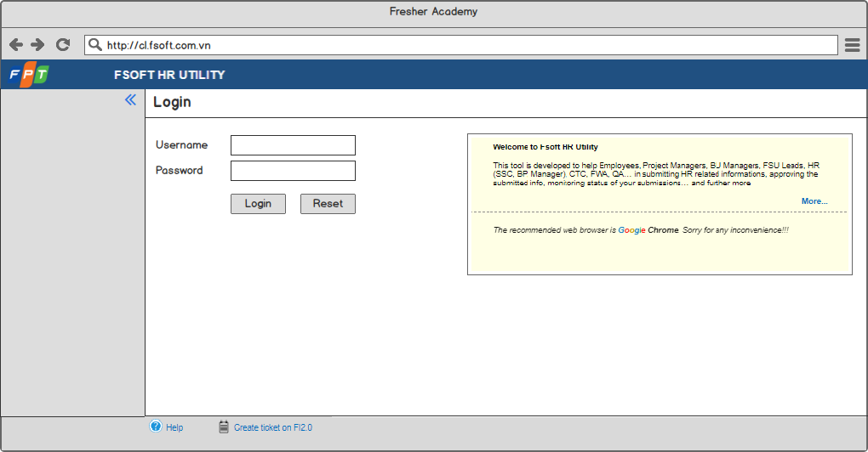

Screen 1: Login screen

|  |  |  |  |  |  |  |
| --- | --- | --- | --- | --- | --- | --- |
| **#** | **Component** | **Comp. Type** | **Editable** | **Mandatory** | **Default Value** | **Description** |
| 1 | Screen Name | Label | No | N/A. | N/A. | This field display text: “Login”. |
| 2 | Username | Text Box | Yes | Yes | N/A. | * This field allows user to input username to log in to the system. * This field gets all values of [Account] field in “User information” entity. |
| 3 | Password | Text Box | Yes | Yes | N/A. | * This field allows user to input password to log in to the system. * This field gets all values of [Password] field in “User information” entity. * The inputted password is displayed as *****. |
| 4 | Log in | Button | N/A. | N/A. | N/A. | * This button allows user to log in to the system. * Refer to ­­UC1: Log in for more details. |
| 5 | Reset | Button | N/A. | N/A. | N/A. | * This button allows user to reboot log in screen forcibly. * Once user clicks on this button, system will clear the inputted information and allow user to input information to log in to the system again. |
| 6 | Introduction Corner | Text Area | N/A. | N/A. | N/A. | * This area displays introduction information of the system. * The logic behind of this area is the same as current tool. |

### Landing Page - TBU

This is Landing Page.

In order to access this screen, user has to be logged in to the system successfully.

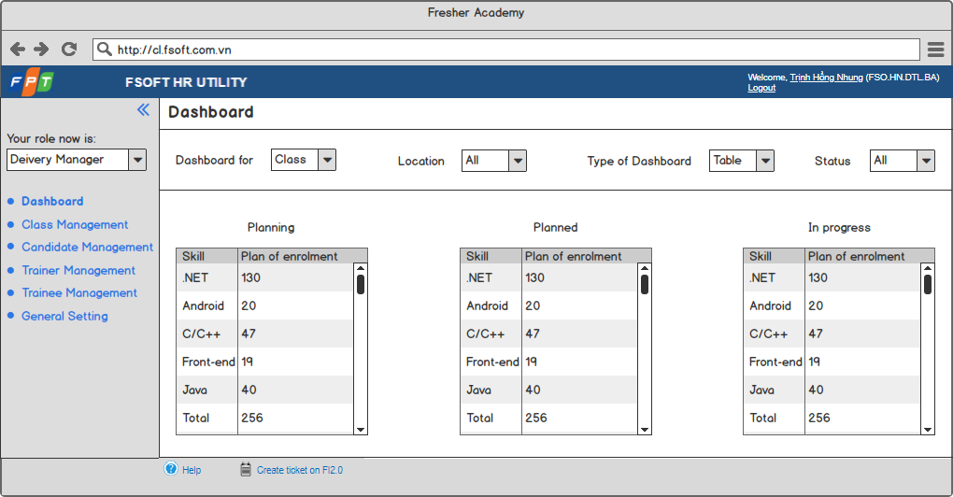

Screen 2: Landing Page

|  |  |  |  |  |  |  |
| --- | --- | --- | --- | --- | --- | --- |
| **#** | **Component** | **Comp. Type** | **Editable** | **Mandatory** | **Default Value** | **Description** |
| 1 | Screen Name | Label | No | N/A. | N/A. | This field displays text: “Dashboard”. |
| 2 | Dashboard for | Drop Down List | Yes | N/A. | Class | * This drop down list allows user to select object of dashboard displayed below. * Value list:   + Class.   + Candidate.   + Trainee.   + Trainer. |
| 3 | Location | Drop Down List | Yes | N/A. | All | * This drop down list allows user to select which location of object displayed in dashboard below. * This field gets all values of [Location Name] field of “Location” entity and “All” value. |
| 4 | Type of Dashboard | Drop Down List | Yes | N/A. | Table | * This drop down list allows user to select type of dashboard displayed. * Value list:   + Table.   + Chart. |
| 5 | Status | Drop Down List | Yes | N/A. | All | * This drop down list allows user to select which status of object displayed in dashboard below. * This field gets all values of [Status] field of object selected in [Dashboard for] field and “All” value. |
| 6 | Dashboard area | N/A | N/A | N/A. | N/A. | * This area displays corresponding dashboard basing on selected criteria. * This area needs to be updated later on. |

## Class Management

### Class listing

This screen is to display all existing classes regardless of its status.

In order to access this screen, user has to do the following steps:

* Log in successfully.
* Click on “Class Management” tab.

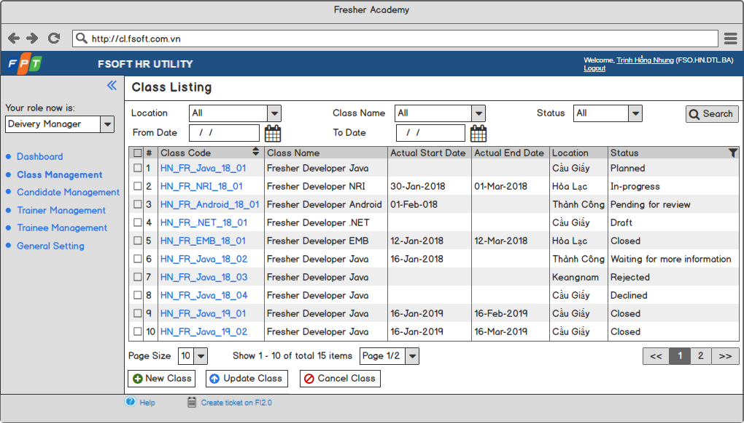

Screen 3: Class in listing view mode

|  |  |  |  |  |  |  |
| --- | --- | --- | --- | --- | --- | --- |
| **#** | **Component** | **Comp. Type** | **Editable** | **Mandatory** | **Default Value** | **Description** |
| 1 | Screen Name | Label | No | N/A. | N/A. | This field displays text: “Class Listing”. |
| 2 | Search Area:   * Display search criteria and “Search” button. * Allow user to search class. | | | | | |
| Location | Drop Down List | Yes | N/A. | All | * This drop down list allows user to select location to search class. * This field gets all values of [Location Name] field of “Location” entity and “All” value. |
| Class Name | Text Box | Yes | N/A. | N/A. | This field allows user to input class name to search class. |
| Status | Drop Down List | Yes | N/A. | All | * This drop down list allows user to select which status of object displayed in dashboard below. * This field gets all values of [Status] field of class and “All” value. |
| From Date | Date Time | Yes | N/A. | N/A. | * This field allows user to input actual start date to search class. * Date format: DD-MM-YYYY. * Cannot input future date. |
| To Date | Date Time | Yes | N/A. | N/A. | * This field allows user to input actual end date to search class. * Date format: DD-MM-YYYY. * Cannot input future date. |
| Search | Button | N/A. | N/A. | N/A. | * This button allows user to search class basing on selected criteria. * Refer to UC6: Search Class for more details. |
| 3 | Class Listing Table:   * Display all existing classes. * Sorted ascending by Class Code column by default. | | | | | |
| Check Box | Column | N/A. | N/A. | No | * This check box allows user to select class(es) to apply bulk action such as cancel, update,… * Once user selects the check box on the column header, all check boxes below are also selected. |
| # | Column | N/A. | N/A. | N/A. | This column displays numerical order of each item. |
| Class Code | Column | N/A. | N/A. | N/A. | * This column displays class code highlighted in blue of each item. * Once user clicks on an class code, system will redirect user to the detailed screen of the selected item. |
| Class Name | Column | N/A. | N/A. | N/A. | This column displays name of each item. |
| Actual Start Date | Column | N/A. | N/A. | N/A. | This column display actual start date of each item. |
| Actual End Date | Column | N/A. | N/A. | N/A. | This column display actual end date of each item. |
| Status | Column | N/A. | N/A. | N/A. | * This column displays status of each item. * This column allows user to filter. |
| 4 | Paging: Display paging information. | | | | | |
| Page Size | Drop Down List | Yes | N/A. | 10 | * This drop down list allows user to select the number of items displayed in a page. * Value list:   + 10.   + 20.   + 30.   + 50.   + 100. |
| Number of Item Info | Label | No | N/A. | N/A. | * This field displays information about number of items displayed in page. * Format is Show X – Y of total Z items. In that:   + X: The numerical number of first item in page.   + Y: The numerical number of last item in page.   + Z: The total number of items. |
| Page Redirection | Drop Down List | Yes | N/A. | N/A. | * This drop down list allows user to access to another page. * The number of values in this list is calculated as:   + Integer part of division between max value in # column and the selected value of [Page Size] field in case completely divided.   + Integer part of division between max value in # column and the selected value of [Page Size] field + 1 in case not completely divided. * Value format is Page X/Y. In that:   + X: Numerical order of current page.   + Y: Number of values in drop down list. * Once user select a value in list, system will redirect user to the page having numerical order same as X. |
| Previous | Button | N/A. | N/A. | N/A. | * This button allows user to redirect to the previous page. * This button is disabled when current page is the 1st page. |
| Page | Button | N/A. | N/A. | N/A. | * These button allows user to redirect to any page. * The number of button is equal to the number of values in drop down list. * Current page is highlighted in dark grey. |
| Next | Button | N/A. | N/A. | N/A. | * This button allows user to redirect to the next page. * This button is disabled when current page is the last page. |
| 5 | New Class | Button | N/A. | N/A. | N/A. | * This button allows user to create a new class. * Refer to UC3: Create a new Class for more details. |
| 6 | Update Class | Button | N/A. | N/A. | N/A. | * This button allows user to update class(es). * Refer to UC4: Update an existing Class for more details. |
| 7 | Cancel Class | Button | N/A. | N/A. | N/A. | * This button allows user to cancel class(es). * Refer to UC7: Cancel Class for more details. |

### Information Tab – create & edit mode

This screen is to create a new Class.

In order to access this screen in create mode, user has to do the following steps:

* Log in successfully.
* Click on “Class Management” tab.
* Click on “New Class” button.

This screen is also to update an existing Class.

In order to access this screen in edit mode, user has to do the following steps:

* Log in successfully.
* Click on “Class Management” tab.
* Select a class.
* Click on “Update Class” button.

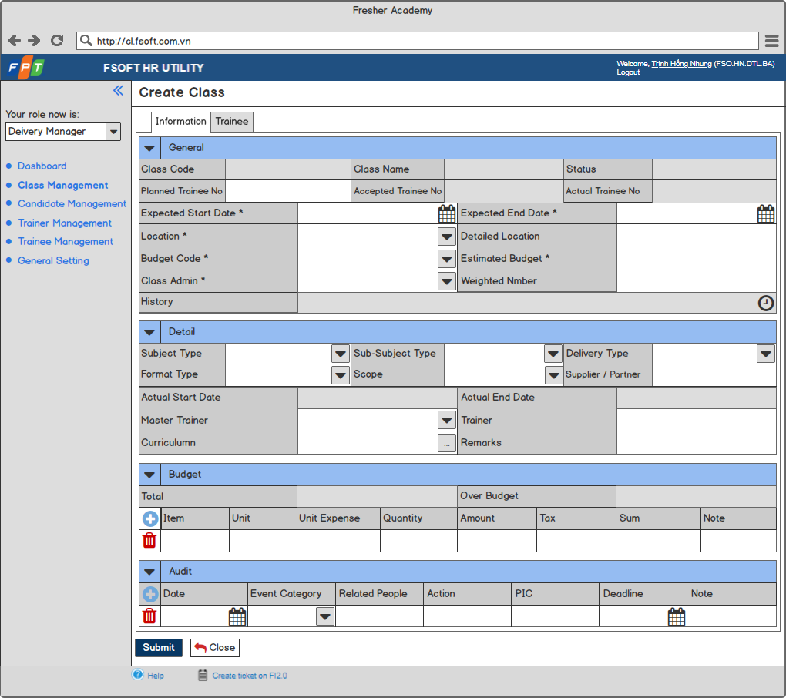

Screen 4: Class in create & edit mode

### Information Tab – view mode

This screen is to view an existing Class.

In order to access this screen, user has to do the following steps:

* Log in successfully.
* Click on “Class Management” tab.
* Select a class.

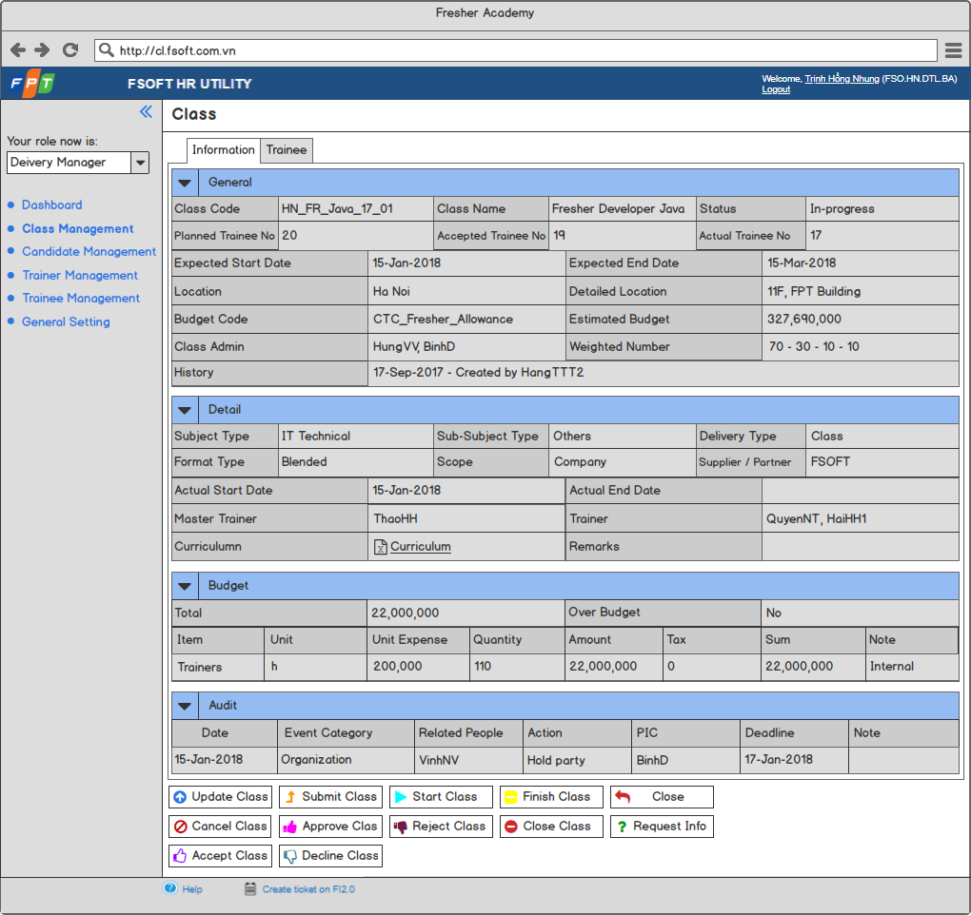

Screen 5: Class in view mode

|  |  |  |  |  |  |  |
| --- | --- | --- | --- | --- | --- | --- |
| **#** | **Component** | **Comp. Type** | **Editable** | **Mandatory** | **Default Value** | **Description** |
| 1 | Screen Name | Label | No | N/A. | N/A. | * This field displays text: “Create Class” in create mode. * This field displays text: “Update Class” in edit mode. * This field displays text: “Class” in view mode. |
| 2 | Tab:   * Display components of Class. * Display “Information” tab by default. | | | | | |
| Information | Tab | No | N/A. | N/A. | This tab displays class information. |
| Trainee | Tab | No | N/A. | N/A. | This tab displays trainee information in class. |
| 3 | General Table: Display general information configured by Delivery Manager of a class. | | | | | |
| Collapse / Expand | Icon | No | N/A. | N/A. | This icon allows user to collapse / expand general table. |
| Table Name | Label | No | N/A. | N/A. | * This field displays text: “General”. |
| Class Code | Label | No | N/A. | N/A. | * This field is auto-generated by system. * Code format: Site_FR_Skill_YY_XX or Site_CP_Skill_YY_XX. In that:   + Site: Acronym of location of class.   + FR / CP: Type of Class:     - FR: Fresher.     - CP: Campus Link.   + Skill: Skill of Class   + YY: Year.   + XX: Serial number of each skill. |
| Class Name | Label | No | N/A. | N/A. | * This field is auto-generated by system. * Name format: Fresher Position Skill. * Example: Fresher Developer Java. |
| Planned Trainee No | Numeric | Yes | N/A. | N/A. | This field allows user to input planned number of trainee joining class. |
| Accepted Trainee No | Label | No | N/A. | N/A. | * This field displays accepted number of trainee joining class. * The value of this field is updated after Delivery Manager updates number of trainees in “Trainee” tab by importing, adding, removing successfully. |
| Actual Trainee No | Label | No | N/A. | N/A. | * This field displays actual number of trainee joining class. * The value of this field is updated as the number of trainees having [Status in Class] field = “Passed” or “Failed” after Delivery Manager closes class successfully. |
| Expected Start Date | Date Time | Yes | Yes | <<Current date>> | * This field allows user to input expected start date of class. * Date format: DD-MM-YYYY. * Cannot input past date. |
| Expected End Date | Date Time | Yes | Yes | <<Current date>> | * This field allows user to input expected end date of class. * Date format: DD-MM-YYYY. * Cannot input past date. |
| Location | Drop Down List | Yes | Yes | N/A. | * This drop down list allows user to select location of class. * This field gets all values of [Location Name] field of “Location”. |
| Detailed Location | Text Box | Yes | No | N/A. | This field allows user to input detailed location of class. |
| Budget Code | Drop Down list | Yes | Yes | N/A. | * This drop down list allows user to select budget code of class. * Value list:   + CTC_Project_ADP.   + CTC_Fresher_Allowance.   + CTC_Fresher_Training.   + CTC_Specific_Fresher_Allowance.   + CTC_Specific_Fresher_Training.   + CTC_Specific_Fresher_Training_Award.   + CTC_FU.   + CTC_Uni. |
| Estimated Budget | Numeric | Yes | Yes | N/A. | This field allows user to input estimated budget for class. |
| Class Admin | Multiple Choice | Yes | Yes | N/A. | * This field allows user to select class admin(s) for class. * This field gets all values from [Account] field of “Class Admin” entity. * Class Admin format when inputting 02 Class Admins above: Class Admin 1, Class Admin 2. |
| Weighted Number | Text Box | Yes | No | N/A. | * This field allows user to input weighted number for class. * Format: W - X – Y – Z. In that:   + W: Weighted number for Academic Mark.   + X: Weighted number for Disciplinary Point.   + Y: Weighted number for Bonus Point.   + Z: Weighted number for Penalty point. |
| History | Label | No | N/A. | N/A. | * This field displays history of current item. * Once user takes any action with current item, system will auto-update this field. |
| 4 | Detail Table: Display detailed information configured by Class Admin of a class. | | | | | |
| Collapse / Expand | Icon | No | N/A. | N/A. | This icon allows user to collapse / expand detail table. |
| Table Name | Label | No | N/A. | N/A. | This field displays text: “Detail”. |
| Subject Type | Drop Down List | Yes | N/A. | N/A. | * This drop down list allows user to select subject type of class. * Value list:   + Organizational Overview & Culture.   + Company Process.   + Standard Process.   + IT Technical.   + Non-IT Technical.   + Foreign Language.   + Soft Skill.   + Management. |
| Sub-Subject Type | Drop Down List | Yes | N/A. | N/A. | * This drop down list allows user to select sub-subject type of class. * Value list:   + Cloud.   + Big Data.   + CAD.   + CAE.   + SAP.   + IT General.   + Test.   + Others. |
| Delivery Type | Drop Down List | Yes | N/A. | N/A. | * This drop down list allows user to select delivery type of class. * Value list:   + Class.   + Seminar.   + Exam.   + Contest.   + Certificate.   + Club.   + OJT.   + Others. |
| Format Type | Drop Down List | Yes | N/A. | N/A. | * This drop down list allows user to select format type of class. * Value list:   + Online.   + Offline.   + Blended. |
| Scope | Drop Down List | Yes | N/A. | N/A. | * This drop down list allows user to select scope type of class. * Value list:   + Company.   + Unit.   + Outside. |
| Supplier / Partner | Text Box | Yes | N/A. | N/A. | This field allows user to input supplier / partner of class. |
| Actual Start Date | Label | No | N/A. | N/A. | * This field is updated by the system. * The value of this field is equal to the date when Class Admin clicks on “Start Class” button. * Date format: DD-MM-YYYY. |
| Actual End Date | Label | No | N/A. | N/A. | * This field is updated by the system. * The value of this field is equal to the date when Delivery Manager clicks on “Close Class” button. * Date format: DD-MM-YYYY. |
| Master Trainer | Drop Down List | Yes | N/A. | N/A. | * This drop down list allows user to select master trainer of class. * This field gets all values from [Account] field of “Trainer” entity. |
| Trainer | Multiple Choice | Yes | N/A. | N/A. | * This field allows user to select trainer(s) for class. * This field gets all values from [Account] field of “Trainer” entity. * Trainer format when inputting 02 Trainers above: Trainer 1, Trainer 2. |
| Curriculum | Button | N/A. | N/A. | N/A. | * This field displays button allowing user to upload curriculum file from local. * The logic behind of this button is the same as current tool. |
| Remarks | Text Box | Yes | N/A. | N/A. | This field allows user to input remarks for class. |
| 5 | Budget Table: Display budget information of a class. | | | | | |
| Collapse / Expand | Icon | No | N/A. | N/A. | This icon allows user to collapse / expand budget table. |
| Table Name | Label | No | N/A. | N/A. | This field displays text: “Budget”. |
| Total | Label | No | N/A. | N/A. | * This field displays total budget of class. * This field is calculated by the system as the following formula: $$\sum_{k=1}^{n}{\left(Sum k\right)}$$  In that:   * + n: Total number of budgets configured   + k: Budget k in n budgets configured   + Sum k: Value of [Sum_x] field of budget k |
| Over Budget | Label | No | N/A. | N/A. | * This field displays whether inputted budget is over estimated budget of class or not. * This field is calculated by the system as the following rules:   + If the value of [Total] field > the value of [Estimated Budget] field, system will display value for [Over Budget] field as “Yes”.   + If the value of [Total] field ≤ the value of [Estimated Budget] field, system will display value for [Over Budget] field as “No”. |
| Add More Budget | Icon | No | N/A. | N/A. | * This icon allows user to add more a new budget. * Once user clicks on this icon, system will add a new row with [Item_x] field, [Unit_x] field, [Unit_Expense_x] field, [Quantity_x] field, [Amount_x] field, [Tax_x] field, [Sum_x] field, [Note_x] field and delete budget icon. * “x” starts from 1 and x=x+1. |
| Item | Text Box | Yes | N/A. | N/A. | This field allows user to input name of item needing budget. |
| Unit | Text Box | Yes | N/A. | N/A. | This field allows user to input unit of item needing budget. |
| Unit Expense |  |  |  |  | This field allows user to input unit expense of item needing budget. |
| Quantity |  |  |  |  | This field allows user to input quantity of item needing budget. |
| Amount |  |  |  |  | * This field displays amount of budget needed for item. * This field is calculated by the system as the following formula:   *Unit expense * Quantity* |
| Tax |  |  |  |  | This field allows user to input tax of item needing budget. |
| Sum |  |  |  |  | * This field displays sum amount of budget needed for item. * This field is calculated by the system as the following formula:   *Amount + (Amount * Tax)* |
| Note |  |  |  |  | This field allows user to input note for item needing budget. |
| Delete Budget | Icon | No | N/A. | N/A. | This icon allows user to delete a budget. |
| 6 | Audit Table: Display audit information of a class. | | | | | |
| Collapse / Expand | Icon | No | N/A. | N/A. | This icon allows user to collapse / expand audit table. |
| Table Name | Label | No | N/A. | N/A. | This field displays text: “Audit”. |
| Add More Audit | Icon | No | N/A. | N/A. | * This icon allows user to add more a new audit. * Once user clicks on this icon, system will add a new row with [Date_x] field, [Event_Category_x] field, [Related_People_x] field, [Action_x] field, [PIC_x] field, [Deadline_x] field, [Note_x] field and delete audit icon. * “x” starts from 1 and x=x+1. |
| Date | Date Time | Yes | N/A. | N/A. | * This field allows user to input date of audit. * Date format: DD-MM-YYYY. * Cannot input future date. |
| Event Category | Drop Down List | Yes | N/A. | N/A. | * This field allows user to select event category of audit. * Value list:   + Trainer.   + Trainee.   + Courseware.   + Organization.   + Logistics.   + Management.   + Calendar.   + Others. |
| Related People / Party | Text Box | Yes | N/A. | N/A. | This field allows user to input related people or party. |
| Action | Text Box | Yes | N/A. | N/A. | This field allows user to input action for audit. |
| PIC | Text Box | Yes | N/A. | N/A. | This field allows user to input PIC for audit. |
| Deadline | Date Time | Yes | N/A. | N/A. | * This field allows user to input deadline of audit. * Date format: DD-MM-YYYY. * Cannot input future date. |
| Note | Text Box | Yes | N/A. | N/A. | This field allows user to input not for audit. |
| Delete Audit | Icon | No | N/A. | N/A. | This icon allows user to delete an audit. |
| 7 | Submit | Button | N/A. | N/A. | N/A. | * This button allows user to create / update class. * Refer to UC3: Create a new Class for more details of creating new class. * Refer to UC4: Update an existing Class for more details of update an existing class. |
| 8 | Close | Button | N/A. | N/A. | N/A. | This button allows user to discard current action and back to the previous screen. |
| 9 | Update Class | Button | N/A. | N/A. | N/A. | * This button allows user to update class. * Refer to UC4: Update an existing Class for more details. |
| 10 | Submit Class | Button | N/A. | N/A. | N/A. | * This button allows user to submit class. * Refer to UC 11: Submit an existing Class for more details. |
| 11 | Start Class | Button | N/A. | N/A. | N/A. | * This button allows user to start class. * Refer to UC 16: Start an accepted Class for more details. |
| 12 | Finish Class | Button | N/A. | N/A. | N/A. | * This button allows user to finish class. * Refer to UC 17: Finish an in-progress Class for more details. |
| 13 | Cancel Class | Button | N/A. | N/A. | N/A. | * This button allows user to cancel class. * Disabled if user is Class Admin, Trainer, FA Rec. * Refer to UC7: Cancel Class for more details. |
| 14 | Approve Class | Button | N/A. | N/A. | N/A. | * This button allows user to approve class. * Disabled if user is Class Admin, Trainer, FA Rec. * Refer to UC 12: Approve a submitted Class for more details. |
| 15 | Reject Class | Button | N/A. | N/A. | N/A. | * This button allows user to reject class. * Disabled if user is Class Admin, Trainer, FA Rec. * Refer to UC 13: Reject a submitted Class for more details. |
| 16 | Close Class | Button | N/A. | N/A. | N/A. | * This button allows user to close class. * Disabled if user is Class Admin, Trainer, FA Rec. * Refer to UC 18: Close a finished Class for more details. |
| 17 | Request Info | Button | N/A. | N/A. | N/A. | * This button allows user to request for more information of class. * Disabled if user is Class Admin, Trainer, FA Rec. * Refer to UC 19: Request for More Information for more details. |
| 18 | Accept Class | Button | N/A. | N/A. | N/A. | * This button allows user to accept class. * Disabled if user is Delivery Manager, Class Admin, Trainer, FA Rec. * Refer to UC 14: Accept an approved Class for more details. |
| 19 | Decline Class | Button | N/A. | N/A. | N/A. | * This button allows user to decline class. * Disabled if user is Delivery Manager, Class Admin, Trainer, FA Rec. * Refer to UC 15: Decline an approved Class for more details. |

### Trainee Tab – view mode

This screen is to display Trainee List in a Class in view mode.

In order to access this screen, user has to follow the below steps:

* Log in to system successfully.
* Click on “Class Management” tab.
* Click on “Class Code” of a Class.
* Click on “Trainee” tab.

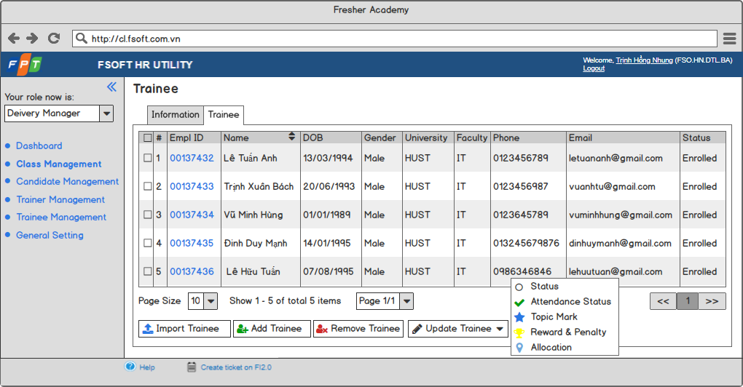

Screen 6: Trainee List in a Class in view mode

|  |  |  |  |  |  |  |
| --- | --- | --- | --- | --- | --- | --- |
| **#** | **Component** | **Comp. Type** | **Editable** | **Mandatory** | **Default Value** | **Description** |
| 1 | Trainee List:   * Display trainee list of current Class. * Sorted ascending by Name by default. | | | | | |
| Check Box | Column | N/A. | N/A. | No | * This check box allows user to select trainees to apply bulk action. * Once user select the check box on the column header, all check boxes below are also selected. |
| # | Column | N/A. | N/A. | N/A. | This column displays numerical order of each item. |
| Empl ID | Column | N/A. | N/A. | N/A. | * This column displays Empl ID highlighted in blue of each item. * Once user clicks on an Empl ID, system will redirect user to the detailed screen of the selected item. |
| Name | Column | N/A. | N/A. | N/A. | This column displays name of each item. |
| DOB | Column | N/A. | N/A. | N/A. | This column displays date of birth of each item. |
| Gender | Column | N/A. | N/A. | N/A. | This column displays gender of each item. |
| University | Column | N/A. | N/A. | N/A. | This column displays university of each item. |
| Faculty | Column | N/A. | N/A. | N/A. | This column displays faculty of each item. |
| Phone | Column | N/A. | N/A. | N/A. | This column displays phone number of each item. |
| Email | Column | N/A. | N/A. | N/A. | This column displays email address of each item. |
| Status | Column | N/A. | N/A. | N/A. | This column displays status in class of each item as “Enrolled”. |
| 2 | Paging: Display paging information. | | | | | |
| Page Size | Drop Down List | Yes | N/A. | N/A. | * This drop down list allows user to select the number of items displayed in a page. * Value list:   + 10.   + 20.   + 30.   + 50.   + 100. |
| Number of Item Info | Label | No | N/A. | N/A. | * This field displays information about number of items displayed in page. * Format is Show X – Y of total Z items. In that:   + X: The numerical number of first item in page.   + Y: The numerical number of last item in page.   + Z: The total number of items. |
| Page Redirection | Drop Down List | Yes | N/A. | N/A. | * This drop down list allows user to access to another page. * The number of values in this list is calculated as the following rules:   + Integer part of division between max value in # column and the selected value of [Page Size] field in case completely divided.   + Integer part of division between max value in # column and the selected value of [Page Size] field + 1 in case not completely divided. * Value format is Page X/Y. In that:   + X: Numerical order of current page.   + Y: Number of values in drop down list. * Once user selects a value in list, system will redirect user to the page having numerical order same as X. |
| Previous | Button | N/A. | N/A. | N/A. | * This button allows user to redirect to the previous page. * This button is disabled when current page is the 1st page. |
| Page | Button | N/A. | N/A. | N/A. | * These button allows user to redirect to any page. * The number of button is equal to the number of values in drop down list. * Current page is highlighted in dark grey. |
| Next | Button | N/A. | N/A. | N/A. | * This button allows user to redirect to the next page. * This button is disabled when current page is the last page. |
| 3 | Import Trainee | Button | N/A. | N/A. | N/A. | * This button allows user to import trainee(s) to class from excel file. * Refer to UC 8: Import Trainee to Class for more details. |
| 4 | Add Trainee | Button | N/A. | N/A. | N/A. | * This button allows user to add trainee(s) to class. * Refer to UC 9: Add Trainee to Class for more details. |
| 5 | Remove Trainee | Button | N/A. | N/A. | N/A. | * This button allows user to remove trainee(s) from Class. * This button is disabled if user selects no trainee. * Refer to UC 10: Remove Trainee from Class for more details. |
| 6 | Update Trainee | Button | N/A. | N/A. | N/A. | * This button allows user to update trainee profile of trainee(s). * This button is disabled if user selects no trainee. * Once user clicks on this button, system will display action list:   + Status. Refer to UC 20: Update Status in Class of Trainee in a Class for more details.   + Attendance Status. Refer to UC 21: Update Attendance Status of Trainee(s) in a Class for more details.   + Topic Mark. Refer to UC 22: Update Topic Mark of Trainee(s) in a Class for more details.   + Reward and Penalty. Refer to UC 23: Update Reward and Penalty of Trainee(s) in a Class for more details.   + Allocation. Refer to UC 24: Update Allocation of Trainee(s) in a Class for more details. |

### Trainee Tab – Import Trainee

This screen is to import Trainee List to Class from Excel file.

In order to access this screen, user has to do the following steps:

* Log in successfully.
* Click on “Class Management” tab.
* Click on “Class Code” of a Class.
* Click on “Trainee” tab.
* Click on “Import Trainee” button.

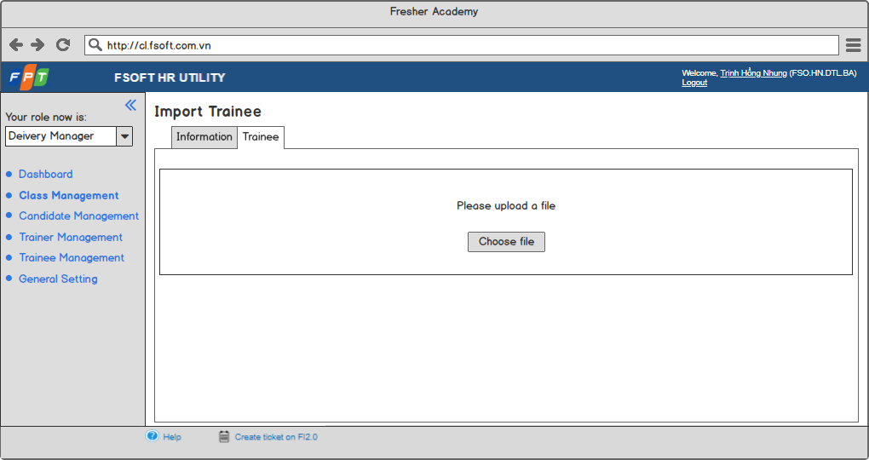

Screen 7: Screen for Delivery Manager to import Trainee to Class

|  |  |  |  |  |  |  |
| --- | --- | --- | --- | --- | --- | --- |
| **#** | **Component** | **Comp. Type** | **Editable** | **Mandatory** | **Default Value** | **Description** |
| 1 | Guideline | Label | No | N/A. | N/A. | This field displays text: “Please upload a file”. |
| 2 | Choose file | Button | N/A. | N/A. | N/A. | * This button allows user to upload a file from local to import. * Refer to UC 8: Import Trainee to Class for more details. |

### Trainee Tab – Add Trainee

This pop-up is to add Trainee(s) to Class.

In order to access this screen, user has to do the following steps:

* Log in successfully.
* Click on “Class Management” tab.
* Click on “Class Code” of a Class.
* Click on “Trainee” tab.
* Click on “Add Trainee” button.

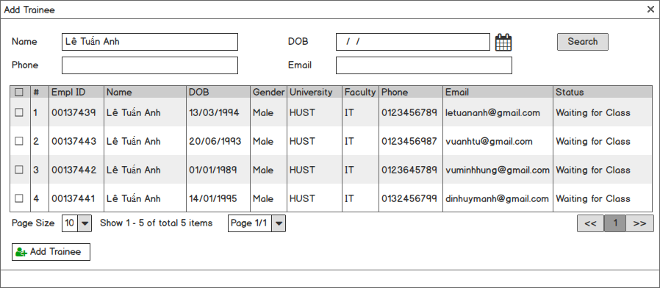

**Screen 8: Pop-up for Delivery Manager to add Trainee to Class**

|  |  |  |  |  |  |  |
| --- | --- | --- | --- | --- | --- | --- |
| **#** | **Component** | **Comp. Type** | **Editable** | **Mandatory** | **Default Value** | **Description** |
| 1 | Pop-up Name | Label | No | N/A. | N/A. | This field displays text: “Add Trainee”. |
| 2 | Search Area: Display search criteria and “Search” button. | | | | | |
| Name | Text Box | Yes | No | N/A. | This field allows user to input trainee name. |
| DOB | Date Time | Yes | No | N/A. | * This field allows user to select date of birth of trainee to search. * Date format: DD/MM/YYYY. * Cannot input future date. |
| Phone | Numeric | Yes | No | N/A. | This field allows user to input trainee phone number to search. |
| Email | Text Box | Yes | No | N/A. | This field allows user to input trainee email address to search. |
| Search | Button | N/A. | N/A. | N/A. | * This button allows user to search trainee to add to class. * Once user clicks on this button, system will display all satisfied trainees to the table below. * The logic to search trainee follows current tool. * Refer to UC 9: Add Trainee to Class for more details. |
| 3 | Paging: Display paging information. | | | | | |
| Page Size | Drop Down List | Yes | N/A. | N/A. | * This drop down list allows user to select the number of items displayed in a page. * Value list:   + 10.   + 20.   + 30.   + 50.   + 100. |
| Number of Item Info | Label | No | N/A. | N/A. | * This field displays information about number of items displayed in page. * Format is Show X – Y of total Z items. In that:   + X: The numerical number of first item in page.   + Y: The numerical number of last item in page.   + Z: The total number of items. |
| Page Redirection | Drop Down List | Yes | N/A. | N/A. | * This drop down list allows user to access to another page. * The number of values in this list is calculated as:   + Integer part of division between max value in # column and the selected value of [Page Size] field in case completely divided.   + Integer part of division between max value in # column and the selected value of [Page Size] field + 1 in case not completely divided. * Value format is Page X/Y. In that:   + X: Numerical order of current page.   + Y: Number of values in drop down list. * Once user selects a value in list, system will redirect user to the page having numerical order same as X. |
| Previous | Button | N/A. | N/A. | N/A. | * This button allows user to redirect to the previous page. * This button is disabled when current page is the 1st page. |
| Page | Button | N/A. | N/A. | N/A. | * These button allows user to redirect to any page. * The number of button is equal to the number of values in drop down list. * Current page is highlighted in dark grey. |
| Next | Button | N/A. | N/A. | N/A. | * This button allows user to redirect to the next page. * This button is disabled when current page is the last page. |
| 4 | Add Trainee | Button | N/A. | N/A. | N/A. | * This button allows user to add selected trainee(s) to current class. * Refer to UC 9: Add Trainee to Class for more details. |

### Trainee Tab – Update Status in Class of Trainee in a Class

This Pop-up is used to update Status in Class of Trainee(s) in a Class.

In order to access this pop-up, user has to do the following steps:

* Log in successfully.
* Click on “Class Management” tab.
* Click on “Trainee’ tab.
* Select Trainee(s) by selecting check box(es).
* Click on “Update Trainee” button.
* Click on “Status” action.

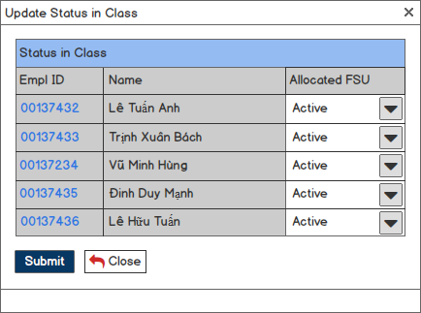

**Screen 9: Pop-up for Class Admin to update Status in Class of Trainee(s) in a Class**

|  |  |  |  |  |  |  |
| --- | --- | --- | --- | --- | --- | --- |
| **#** | **Component** | **Comp. Type** | **Editable** | **Mandatory** | **Default Value** | **Description** |
| 1 | Screen Name | Label | No | N/A. | N/A. | This field displays text: “Update Status in Class”. |
| 3 | Status in Class table: Display Status of the selected trainee(s) in Class. | | | | | |
| Table Name | Label | No | N/A. | N/A. | This field displays text: “Status in Class”. |
| Empl ID | Column | N/A. | N/A. | N/A. | * This column displays Empl ID highlighted in blue of each item. * Once user clicks on an Empl ID, system will redirect user to the detailed screen of the selected item. |
| Name | Column | N/A. | N/A. | N/A. | This column displays name of each item. |
| Status | Column | N/A. | N/A. | N/A. | * This column allow user to update status in class of each item. * Value list:   + Active.   + Deferred.   + Drop-out. |
| 4 | Submit | Button | N/A. | N/A. | N/A. | * This button allows user to save all changes with attendance status in the selected milestone of the selected trainees in current class. * Refer to UC 20: Update Status in Class of Trainee in a Class for more details. |
| 5 | Close | Button | N/A. | N/A. | N/A. | This button allows user to close pop-up and stay in current screen. |

### Trainee Tab – Update Attendance Status of Trainee(s) in a Class

This Pop-up is used to update Attendance Status of Trainee(s) in a Class.

In order to access this Pop-up, user has to do the following steps:

* Log in successfully.
* Click on “Class Management” tab.
* Click on “Trainee’ tab.
* Select Trainee(s) by selecting check box(es).
* Click on “Update Trainee” button.
* Click on “Attendance Status” action.

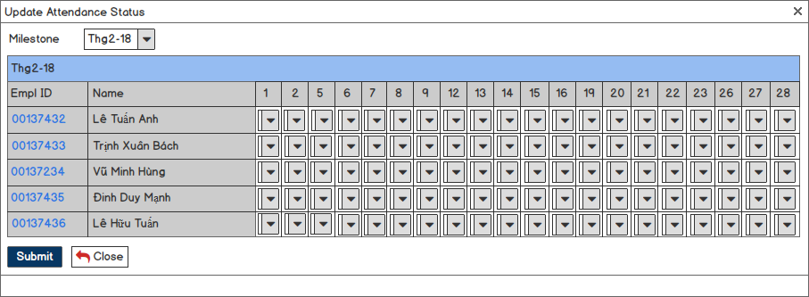

**Screen 10: Pop-up for Class Admin to update Attendance Status of Trainee(s) in a Class**

|  |  |  |  |  |  |  |
| --- | --- | --- | --- | --- | --- | --- |
| **#** | **Component** | **Comp. Type** | **Editable** | **Mandatory** | **Default Value** | **Description** |
| 1 | Screen Name | Label | No | N/A. | N/A. | This field displays text: “Update Attendance Status”. |
| 2 | Milestone | Drop Down List | Yes | N/A. | N/A. | * This drop down list allows user to select which milestone to update attendance status. * This drop down list gets all values of [Milestone Name] field in Milestone Configuration table of all selected trainees in corresponding class. |
| 3 | Attendance Status table: Display attendance status of the selected trainee(s) in each lesson of the selected milestone. | | | | | |
| Table Name | Label | No | N/A. | N/A. | This field displays name of the selected milestone. |
| Empl ID | Column | N/A. | N/A. | N/A. | * This column displays Empl ID highlighted in blue of each item. * Once user clicks on an Empl ID, system will redirect user to the detailed screen of the selected item. |
| Name | Column | N/A. | N/A. | N/A. | This column displays name of each item. |
| Learning Day | Column | N/A. | N/A. | N/A. | * The remaining columns display learning days in the selected milestone. * The number of column is equal to the number of day which trainee needs to join in milestone except for weekend and holidays. |
| Status_Day | Drop Down List | Yes | No | P | * This drop down list allows user to select attendance status in learning day in the selected milestone of the selected trainees in corresponding class. * Value list:   + P (= Present).   + A (= Absent).   + E (= Early Leaving).   + L (= Late Coming).   + An (= Absent with no permission).   + En (= Early Leaving with no permission).   + Ln (= Late Coming with no permission). * Day is equal to date of each learning day in corresponding milestone. |
| 4 | Submit | Button | N/A. | N/A. | N/A. | * This button allows user to save all changes with attendance status in the selected milestone of the selected trainees in current class. * Refer to UC 21: Update Attendance Status of Trainee(s) in a Class for more details. |
| 5 | Close | Button | N/A. | N/A. | N/A. | This button allows user to close pop-up and stay in current screen. |

### Trainee Tab – Update Topic Mark of Trainee(s) in a Class

This Pop-up is used to update Topic Mark of Trainee(s) in a Class.

In order to access this Pop-up, user has to do the following steps:

* Log in successfully.
* Click on “Class Management” tab.
* Click on “Trainee’ tab.
* Select Trainee(s) by selecting check box(es).
* Click on “Update Trainee” button.
* Click on “Topic Mark” action.

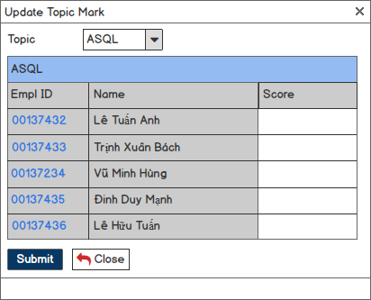

**Screen 11: Pop-up for Class Admin to update Topic Mark of Trainee(s) in a Class**

|  |  |  |  |  |  |  |
| --- | --- | --- | --- | --- | --- | --- |
| **#** | **Component** | **Comp. Type** | **Editable** | **Mandatory** | **Default Value** | **Description** |
| 1 | Screen Name | Label | No | N/A. | N/A. | This field displays text: “Update Topic Mark”. |
| 2 | Topic | Drop Down List | Yes | N/A. | N/A. | * This drop down list allows user to select which topic to update topic mark. * This drop down list gets all values of [Topic] field in Milestone Configuration table of all selected trainees in corresponding class. |
| 3 | Topic Mark table: Display topic mark of the selected trainee(s). | | | | | |
| Table Name | Label | No | N/A. | N/A. | This field displays name of the selected topic. |
| Empl ID | Column | N/A. | N/A. | N/A. | * This column displays Empl ID highlighted in blue of each item. * Once user clicks on an Empl ID, system will redirect user to the detailed screen of the selected item. |
| Name | Column | N/A. | N/A. | N/A. | This column displays name of each item. |
| Score | Column | N/A. | N/A. | N/A. | This column allow user to input score in the selected topic of the selected trainee(s). |
| 4 | Submit | Button | N/A. | N/A. | N/A. | * This button allows user to save all changes with attendance status in the selected milestone of the selected trainees in current class. * Refer to UC 22: Update Topic Mark of Trainee(s) in a Class for more details. |
| 5 | Close | Button | N/A. | N/A. | N/A. | This button allows user to close pop-up and stay in current screen. |

### Trainee Tab – Update Reward & Penalty of Trainee(s) in a Class

This Pop-up is used to update Reward & Penalty of Trainee(s) in a Class.

In order to access this Pop-up, user has to do the following steps:

* Log in successfully.
* Click on “Class Management” tab.
* Click on “Trainee’ tab.
* Select Trainee(s) by selecting check box(es).
* Click on “Update Trainee” button.
* Click on “Reward & Penalty” action.

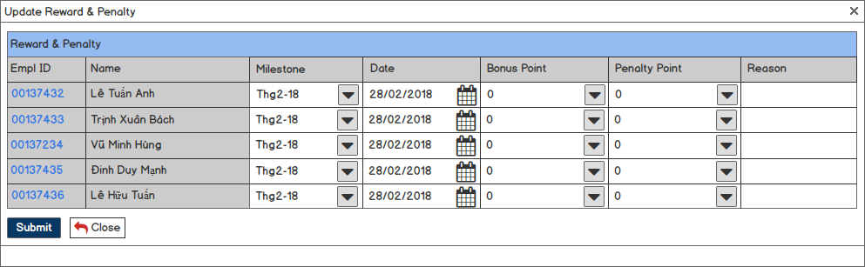

**Screen 12: Pop-up for Class Admin to update Reward & Penalty of Trainee(s) in a Class**

|  |  |  |  |  |  |  |
| --- | --- | --- | --- | --- | --- | --- |
| **#** | **Component** | **Comp. Type** | **Editable** | **Mandatory** | **Default Value** | **Description** |
| 1 | Screen Name | Label | No | N/A. | N/A. | This field displays text: “Update Reward & Penalty”. |
| 3 | Reward & Penalty table: Display Reward & Penalty of the selected trainee(s). | | | | | |
| Table Name | Label | No | N/A. | N/A. | This field displays text: “Reward & Penalty”. |
| Empl ID | Column | N/A. | N/A. | N/A. | * This column displays Empl ID highlighted in blue of each item. * Once user clicks on an Empl ID, system will redirect user to the detailed screen of the selected item. |
| Name | Column | N/A. | N/A. | N/A. | This column displays name of each item. |
| Milestone | Column | Yes | No | N/A. | * This column allows user to select milestone on which bonus point / penalty point is recorded. * This column gets all values of [Milestone Name] field configured in milestone configuration table. |
| Date | Column | Yes | No | N/A. | * This column allows user to input date on which bonus point / penalty point is recorded. * Date format is DD/MM/YYYY. |
| Bonus Point | Column | Yes | No | 0 | * This column allows user to input bonus point. * 0 ≤ inputted value ≤ 20. * This column is disabled if inputted value for [Penalty Points] field ≠ “0”. |
| Penalty Point | Column | Yes | No | 0 | * This column allows user to input penalty point. * 0 ≤ inputted value ≤ 20. * This column is disabled if inputted value for [Bonus Points] field ≠ “0”. |
| Reason | Column | Yes | No | N/A. | This column allows user to reason for bonus point / penalty point. |
| 4 | Submit | Button | N/A. | N/A. | N/A. | * This button allows user to save all changes with attendance status in the selected milestone of the selected trainees in current class. * Refer to UC 23: Update Reward and Penalty of Trainee(s) in a Class for more details. |
| 5 | Close | Button | N/A. | N/A. | N/A. | This button allows user to close pop-up and stay in current screen. |

### Trainee Tab – Update Allocation of Trainee(s) in a Class

This Pop-up is used to update Allocation of Trainee(s) in a Class.

In order to access this Pop-up, user has to do the following steps:

* Log in successfully.
* Click on “Class Management” tab.
* Click on “Trainee’ tab.
* Select Trainee(s) by selecting check box(es).
* Click on “Update Trainee” button.
* Click on “Allocation” action.

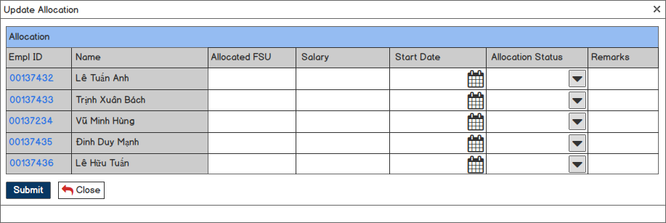

**Screen 13: Pop-up for Class Admin to update Allocation of Trainee(s) in a Class**

|  |  |  |  |  |  |  |
| --- | --- | --- | --- | --- | --- | --- |
| **#** | **Component** | **Comp. Type** | **Editable** | **Mandatory** | **Default Value** | **Description** |
| 1 | Screen Name | Label | No | N/A. | N/A. | This field displays text: “Allocation”. |
| 3 | Allocation table: Display Reward & Penalty of the selected trainee(s). | | | | | |
| Table Name | Label | No | N/A. | N/A. | This field displays text: “Reward & Penalty”. |
| Empl ID | Column | N/A. | N/A. | N/A. | * This column displays Empl ID highlighted in blue of each item. * Once user clicks on an Empl ID, system will redirect user to the detailed screen of the selected item. |
| Name | Column | N/A. | N/A. | N/A. | This column displays name of each item. |
| Milestone | Column | Yes | No | N/A. | * This column allows user to select milestone on which bonus point / penalty point is recorded. * This column gets all values of [Milestone Name] field configured in milestone configuration table. |
| Date | Column | Yes | No | N/A. | * This column allows user to input date on which bonus point / penalty point is recorded. * Date format is DD/MM/YYYY. |
| Bonus Point | Column | Yes | No | 0 | * This column allows user to input bonus point. * 0 ≤ inputted value ≤ 20. * This column is disabled if inputted value for [Penalty Points] field ≠ “0”. |
| Penalty Point | Column | Yes | No | 0 | * This column allows user to input penalty point. * 0 ≤ inputted value ≤ 20. * This column is disabled if inputted value for [Bonus Points] field ≠ “0”. |
| Reason | Column | Yes | No | N/A. | This column allows user to reason for bonus point / penalty point. |
| 4 | Submit | Button | N/A. | N/A. | N/A. | * This button allows user to save all changes with attendance status in the selected milestone of the selected trainees in current class. * Refer to UC 24: Update Allocation of Trainee(s) in a Class for more details. |
| 5 | Close | Button | N/A. | N/A. | N/A. | This button allows user to close pop-up and stay in current screen. |

## Candidate Management

### Candidate Listing

This screen is to display all existing candidates regardless of his/her status.

In order to access this screen, user has to do the following steps:

* Log in successfully.
* Click on “Candidate Management” tab.

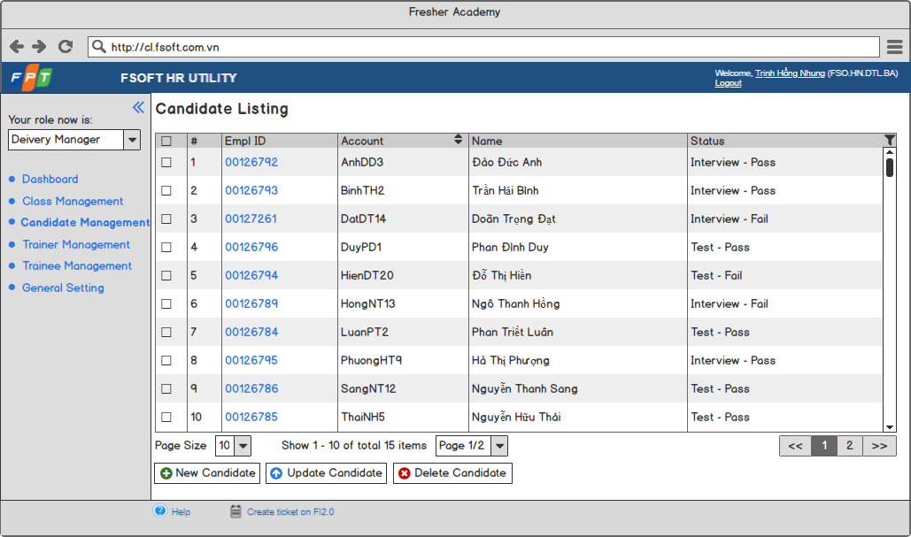

**Screen 14: Candidate in listing view mode**

|  |  |  |  |  |  |  |
| --- | --- | --- | --- | --- | --- | --- |
| **#** | **Component** | **Comp. Type** | **Editable** | **Mandatory** | **Default Value** | **Description** |
| 1 | Screen Name | Label | No | N/A. | N/A. | This field displays text: “Candidate Listing”. |
| 2 | Candidate Listing Table:   * Display all existing candidates. * Sorted ascending by Account column by default. | | | | | |
| Check Box | Column | N/A. | N/A. | No | * This check box allows user to select candidate(s) to apply bulk action such as delete, update status,… * Once user selects the check box on the column header, all check boxes below are also selected. |
| # | Column | N/A. | N/A. | N/A. | This column displays numerical order of each item. |
| Empl ID | Column | N/A. | N/A. | N/A. | * This column displays Empl ID highlighted in blue of each item. * Once user clicks on an Empl ID, system will redirect user to the detailed screen of the selected item. |
| Account | Column | N/A. | N/A. | N/A. | This column displays account of each item. |
| Name | Column | N/A. | N/A. | N/A. | This column displays full name of each item. |
| Status | Column | N/A. | N/A. | N/A. | * This column displays status of each item. * This column allows user to filter. |
| 3 | Paging: Display paging information. | | | | | |
| Page Size | Drop Down List | Yes | N/A. | 10 | * This drop down list allows user to select the number of items displayed in a page. * Value list:   + 10.   + 20.   + 30.   + 50.   + 100. |
| Number of Item Info | Label | No | N/A. | N/A. | * This field displays information about number of items displayed in page. * Format is Show X – Y of total Z items. In that:   + X: The numerical number of first item in page.   + Y: The numerical number of last item in page.   + Z: The total number of items. |
| Page Redirection | Drop Down List | Yes | N/A. | N/A. | * This drop down list allows user to access to another page. * The number of values in this list is calculated as:   + Integer part of division between max value in # column and the selected value of [Page Size] field in case completely divided.   + Integer part of division between max value in # column and the selected value of [Page Size] field + 1 in case not completely divided. * Value format is Page X/Y. In that:   + X: Numerical order of current page.   + Y: Number of values in drop down list. * Once user select a value in list, system will redirect user to the page having numerical order same as X. |
| Previous | Button | N/A. | N/A. | N/A. | * This button allows user to redirect to the previous page. * This button is disabled when current page is the 1st page. |
| Page | Button | N/A. | N/A. | N/A. | * These button allows user to redirect to any page. * The number of button is equal to the number of values in drop down list. * Current page is highlighted in dark grey. |
| Next | Button | N/A. | N/A. | N/A. | * This button allows user to redirect to the next page. * This button is disabled when current page is the last page. |
| 4 | Add Candidate | Button | N/A. | N/A. | N/A. | * This button allows user to create a new candidate profile. * Refer to UC 25: Create a new Candidate Profile for more details. |
| 5 | Update Candidate | Button | N/A. | N/A. | N/A. | * This button allows user to update candidate profile.. * Refer to UC 30: Update Trainee Profile for more details. |
| 6 | Delete Candidate | Button | N/A. | N/A. | N/A. | * This button allows user to delete candidate profile(s). * Refer to UC 32: Delete Trainee Profile for more details. |
| 7 | Transfer Candidate | Button | N/A. | N/A. | N/A. | * This button allows user to transfer candidate profile(s). * Refer to UC 29: Transfer Candidate for more details. |

### Candidate Profile – Create mode

This screen is to create a new Candidate Profile.

In order to access this screen, user has to do the following steps:

* Log in successfully.
* Click on “CandidateManagement” tab.
* Click on “New Candidate” button.

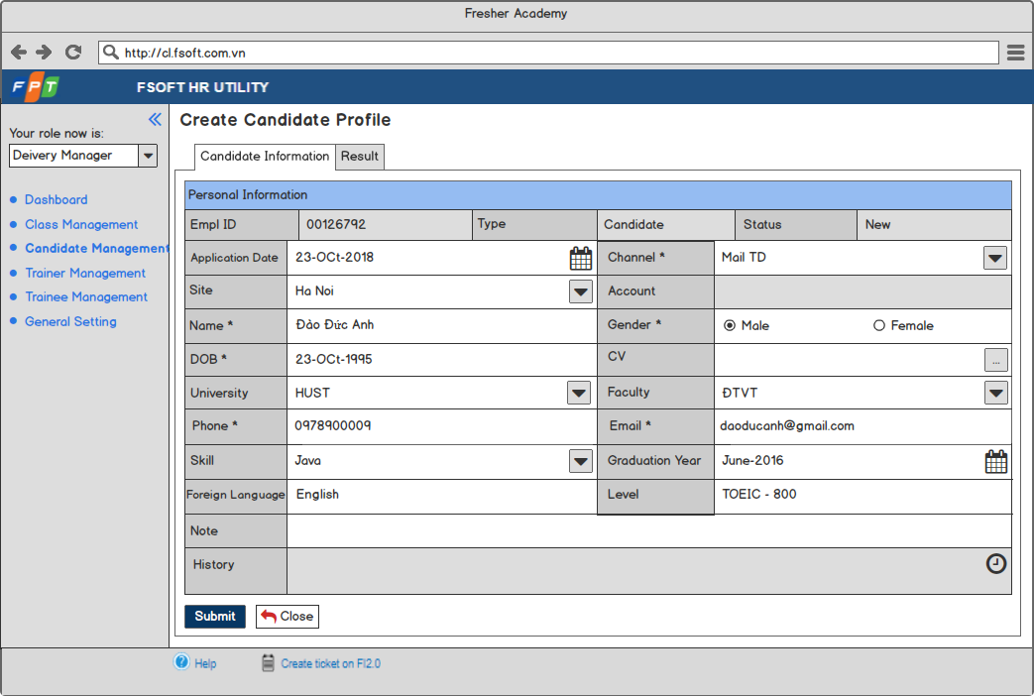

Screen 15: Candidate Profile in create mode

### Candidate Profile – View Candidate Information

This screen is used to view a Candidate Profile.

In order to access this screen, user has to do the following steps:

* Log in successfully.
* Click on “Candidate Management” tab.
* Select a andidate by clicking on Empl ID.

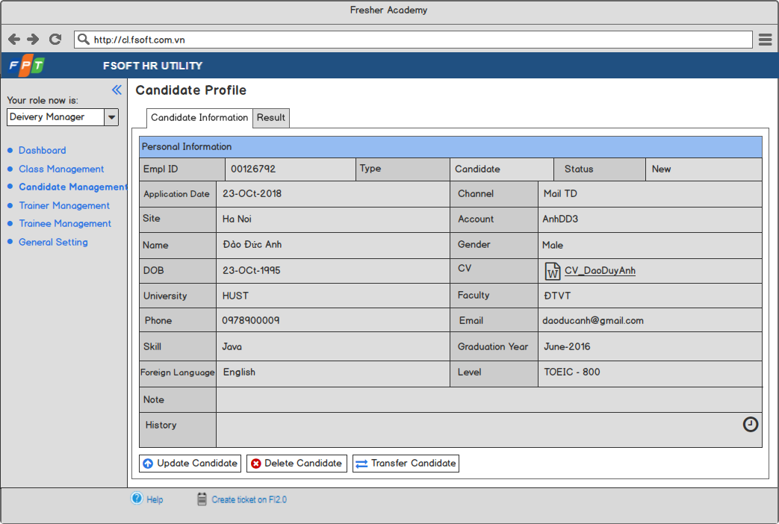

Screen 16: Candidate Profile in view mode – view Candidate Information

### Candidate Profile – Update Candidate Information

This screen is used to update information of an existing candidate.

In order to access this screen, user has to do the following steps:

* Log in successfully.
* Click on “Candidate Management” tab.
* Select a candidate by clicking on Empl ID.
* Click on “Update Candidate” button.

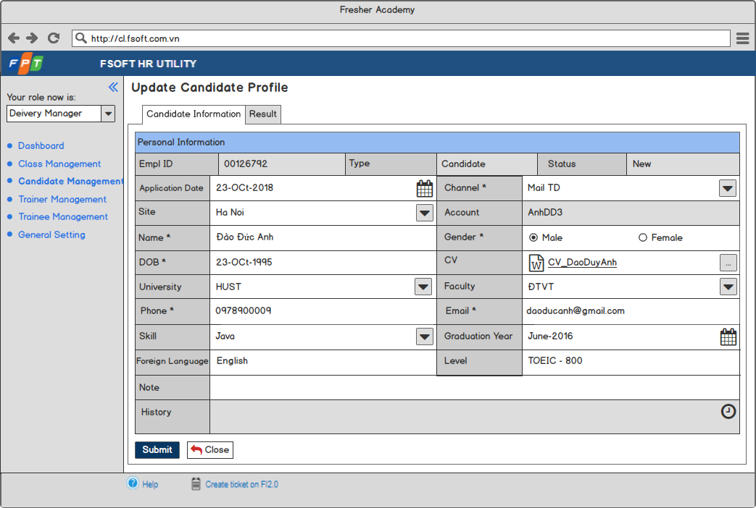

Screen 17: Candidate Profile in edit mode – update Candidate Information

|  |  |  |  |  |  |  |
| --- | --- | --- | --- | --- | --- | --- |
| **#** | **Component** | **Comp. Type** | **Editable** | **Mandatory** | **Default Value** | **Description** |
| 1 | Screen Name | Label | No | N/A. | N/A. | * This field displays text: “Create Candidate Profile” in create mode. * This field displays text: “Update Candidate Profile” in edit mode. * This field displays text: “Candidate Profile” in view mode. |
| 2 | Tab   * Display components of Candidate. * Display “Candidate Information” tab by default. | | | | | |
| Candidate Personal Information | Tab | No | N/A. | N/A. | This tab displays candidate personal information. |
| Candidate Training Result | Tab | No | N/A. | N/A. | This tab displays candidate test result and interview. |
| 3 | Personal Information Table: Display personal information of a candidate. | | | | | |
| Empl ID | Label | No | N/A. | N/A. | This field is auto-generated by system. |
| Type | Label | No | N/A. | N/A. | This field displays text: “Candidate”. |
| Status | Label | No | N/A. | N/A. | * This field is auto-filled by system upon action of user. * Value list:   + New.   + Test – Pass.   + Test – Fail.   + Interview – Test.   + Interview – Fail.   + Transferred. |
| Application Date | Date Time | Yes | No | <<Current date>> | * This field allows user to input application date. * Date format: DD-MM-YYYY. * Cannot input future date. |
| Channel | Drop Down List | Yes | Yes | N/A. | * This drop down list allows user to select channel by which get candidate information. * This field gets all values of [Channel Name] field from “Channel” entity. |
| Site | Drop Down List | Yes | N/A. | All | * This drop down list allows user to select site of candidate. * This field gets all values of [Location Name] field of “Location” entity. |
| Account | Label | No | N/A. | N/A. | This field is auto-generated by system as the following rules:   * Get 1st letter in name. * Get 1st letter in surname. * Get 1st letter in middle names. * Combine as the order: Name_Surname_Middlenames_x. * Look-up to [Account] field in database:   + If any matching: x +1, then check duplicate again.   + If no matching: Set the value of [Account] field of current candidate as Name_Surname_Middlenames_x. |
| Name | Text Box | Yes | Yes | N/A. | This field allows user to input candidate full name. |
| Gender | Radio Button | Yes | Yes | Male | * This field allows user to select candidate gender. * Value list:   + Male.   + Female. |
| DOB | Date Time | Yes | Yes | N/A. | * This field allows user to input candidate date of birth. * Date format is DD/MM/YYYY. * User cannot input future date. |
| CV | Button | N/A. | N/A. | N/A. | * This field displays button allowing user to upload CV of candidate from local. * The logic behind of this button is the same as current tool. |
| University | Drop Down List | No | Yes | N/A. | * This drop down list allows user to select candidate university. * This field gets all values from [University Name] field in University entity and includes “Other” value. * Once user selects “Other”, system will display a text box allowing user to input candidate university below with “Input University here” as guideline text as the following:   Snapshot   * After user inputs candidate university and enters, system will display value for this field as the inputted data and create a new item for University entity with the value of [University Name] field as the inputted data. |
| Faculty | Drop Down List | No | Yes | N/A. | * This drop down list allows user to select candidate faculty. * This field gets all values from [Faculty Name] field in Faculty entity and includes “Other” value. * Once user selects “Other”, system will display a text box allowing user to input candidate faculty below with “Input Faculty here” as guideline text as the following:   Snapshot   * After user inputs candidate faculty and enters, system will display value for this field as the inputted data and create a new item for Faculty entity with the value of [Faculty Name] field as the inputted data. |
| Phone | Numeric | Yes | Yes | N/A. | * This field allows user to input candidate phone number. * 10 ≤ inputted value ≤14. |
| Email | Text Box | Yes | Yes | N/A. | * This field allows user to input candidate email address. * This field follows email format. |
| Skill | Text Box | Yes | N/A. | N/A. | This field allows user to input skills of candidate. |
| Graduation Year | Date Time | Yes | N/A. | N/A. | * This field allows user to select graduation year of candidate. * Date format: MM-YYYY. * Cannot input future date. |
| Foreign Language | Text Box | Yes | N/A. | N/A. | This field allows user to input foreign language of candidate. |
| Level | Text Box | Yes | N/A. | N/A. | This field allows user to input level of foreign language of candidate. |
| Note | Text Box | Yes | N/A. | N/A. | This field allows user to input note for candidate. |
| History | Label | No | N/A. | N/A. | * This field displays history of current item. * Once user takes any action with current item, system will auto-update this field. |
| 4 | Submit | Button | N/A. | N/A. | N/A. | * This button allows user to create / update a new candidate profile. * Refer to UC 25: Create a new Candidate Profile for more details of creating new candidate profile. * Refer to UC 26: Update an existing Candidate for more details of update candidate profile. |
| 5 | Close | Button | N/A. | N/A. | N/A. | This button allows user to discard current action and back to the previous screen. |
| 6 | Update Candidate | Button | N/A. | N/A. | N/A. | * This button allows user to update candidate profile. * Refer to UC 26: Update an existing Candidate for more details. |
| 7 | Delete Candidate | Button | N/A. | N/A. | N/A. | * This button allows user to delete a candidate profile. * Refer to UC 27: Delete an existing Candidate for more details. |
| 8 | Transfer Candidate | Button | N/A. | N/A. | N/A. | * This button allows user to delete a candidate profile. * Refer to UC 29: Transfer Candidate for more details. |

### Candidate Profile – View result

This screen allows users to view result of candidate.

In order to access this screen, user has to do the following steps:

* Log in successfully.
* Click on “Candidate Management” tab.
* Select a Candidate by clicking on Empl ID.
* Click on “Result” tab.

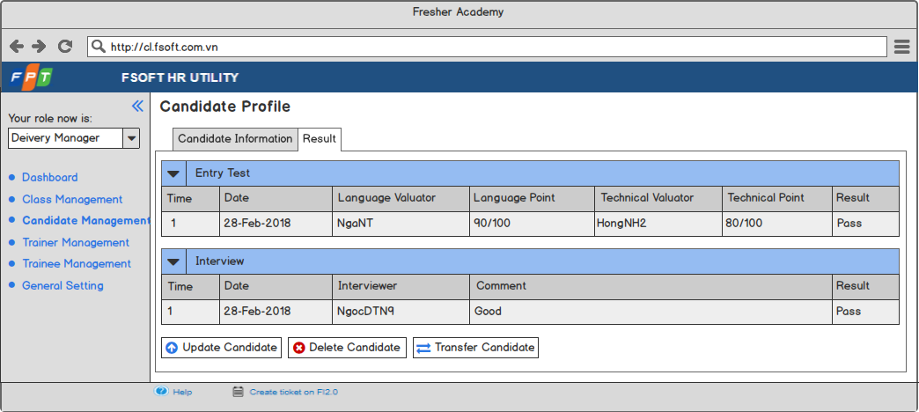

Screen 18: Candidate Profile in view mode – view Result Information

### Candidate Profile – Update Result

This screen is used to update information of an existing candidate.

In order to access this screen, user has to do the following steps:

* Log in successfully.
* Click on “Candidate Management” tab.
* Select a candidate by clicking on Empl ID.
* Click on “Update Candidate” button.
* Select “Result” tab.

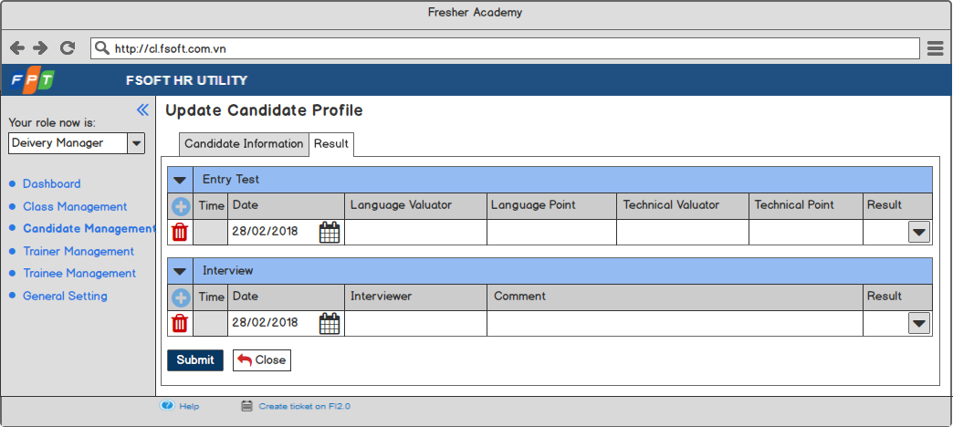

Screen 19: Candidate Profile in edit mode – update Result Information

|  |  |  |  |  |  |  |
| --- | --- | --- | --- | --- | --- | --- |
| **#** | **Component** | **Comp. Type** | **Editable** | **Mandatory** | **Default Value** | **Description** |
| 1 | Screen Name | Label | No | N/A. | N/A. | This field displays text: “Update Candidate Profile”. |
| 2 | Entry Test table: Display information about entry test of candidate. | | | | | |
| Collapse / Expand | Icon | No | N/A. | N/A. | This icon allows user to collapse / expand entry test table. |
| Table Name | Label | No | N/A. | N/A. | This field displays text: “Entry Test”. |
| Add new Entry Test | Icon | No | N/A. | N/A. | * This icon allows user to add more a new entry test result . * Once user clicks on this icon, system will add a new row with [Time_x] field, [Date_x] field, [Language_Valuator_x] field, [Language_Point_x] field, [Technical_Valuator_x] field, [Technical_Point_x] field, [Result_x] field and delete reward & penalty icon. * “x” starts from 1 and x=x+1. |
| Time | Label | No | N/A. | N/A. | This field is auto generated by the system. |
| Date | Date Time | Yes | N/A. | N/A. | * This field allows user to input date on which candidate takes the entry test. * Date format: DD-MM-YYYY. * Cannot input future date. |
| Language Valuator | Text Box | Yes | N/A. | N/A. | This field allows users to input valuator for language. |
| Language Score | Numeric | Yes | N/A. | N/A. | This field allows users to input score for language. |
| Technical Valuator | Text Box | Yes | N/A. | N/A. | This field allows users to input valuator for technical. |
| Technical Score | Numeric | Yes | N/A. | N/A. | This field allows users to input score for technical. |
| Result | Drop Down List | Yes | N/A. | N/A. | * This drop down list allows user to select result for entry test. * Value list:   + Pass.   + Fail. |
| 3 | Submit | Button | N/A. | N/A. | N/A. | * This button allows user to update new candidate profile. * Refer to UC 26: Update an existing Candidate for more details of creating new candidate profile. |
| 4 | Close | Button | N/A. | N/A. | N/A. | This button allows user to discard current action and back to the previous screen. |
| 5 | Update Candidate | Button | N/A. | N/A. | N/A. | * This button allows user to update candidate profile.. * Refer to UC 30: Update Trainee Profile for more details. |
| 6 | Delete Candidate | Button | N/A. | N/A. | N/A. | * This button allows user to delete candidate profile(s). * Refer to UC 32: Delete Trainee Profile for more details. |
| 7 | Transfer Candidate | Button | N/A. | N/A. | N/A. | * This button allows user to transfer candidate profile(s). * Refer to UC 29: Transfer Candidate for more details. |

## Trainee Management

### Trainee Listing

This screen is to display all existing trainees regardless of his/her status.

In order to access this screen, user has to do the following steps:

* Log in successfully.
* Click on “Trainee Management” tab.

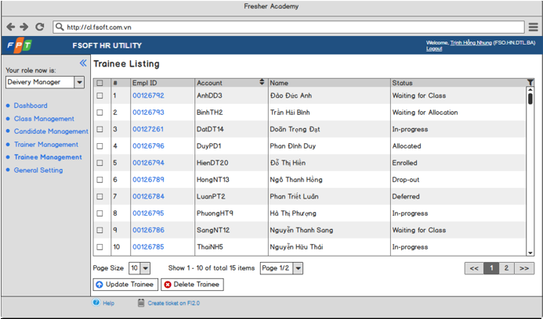

Screen 20: Trainee in listing view mode

|  |  |  |  |  |  |  |
| --- | --- | --- | --- | --- | --- | --- |
| **#** | **Component** | **Comp. Type** | **Editable** | **Mandatory** | **Default Value** | **Description** |
| 1 | Screen Name | Label | No | N/A. | N/A. | This field displays text: “Trainee Listing”. |
| 2 | Trainee Listing Table:   * Display all existing trainees. * Sorted ascending by Account column by default. | | | | | |
| Check Box | Column | N/A. | N/A. | No | * This check box allows user to select trainee(s) to apply bulk action such as delete, update status,… * Once user selects the check box on the column header, all check boxes below are also selected. |
| # | Column | N/A. | N/A. | N/A. | This column displays numerical order of each item. |
| Empl ID | Column | N/A. | N/A. | N/A. | * This column displays Empl ID highlighted in blue of each item. * Once user clicks on an Empl ID, system will redirect user to the detailed screen of the selected item. |
| Account | Column | N/A. | N/A. | N/A. | This column displays account of each item. |
| Name | Column | N/A. | N/A. | N/A. | This column displays full name of each item. |
| Status | Column | N/A. | N/A. | N/A. | * This column displays status of each item. * This column allows user to filter. |
| 3 | Paging: Display paging information. | | | | | |
| Page Size | Drop Down List | Yes | N/A. | 10 | * This drop down list allows user to select the number of items displayed in a page. * Value list:   + 10.   + 20.   + 30.   + 50.   + 100. |
| Number of Item Info | Label | No | N/A. | N/A. | * This field displays information about number of items displayed in page. * Format is Show X – Y of total Z items. In that:   + X: The numerical number of first item in page.   + Y: The numerical number of last item in page.   + Z: The total number of items. |
| Page Redirection | Drop Down List | Yes | N/A. | N/A. | * This drop down list allows user to access to another page. * The number of values in this list is calculated as:   + Integer part of division between max value in # column and the selected value of [Page Size] field in case completely divided.   + Integer part of division between max value in # column and the selected value of [Page Size] field + 1 in case not completely divided. * Value format is Page X/Y. In that:   + X: Numerical order of current page.   + Y: Number of values in drop down list. * Once user select a value in list, system will redirect user to the page having numerical order same as X. |
| Previous | Button | N/A. | N/A. | N/A. | * This button allows user to redirect to the previous page. * This button is disabled when current page is the 1st page. |
| Page | Button | N/A. | N/A. | N/A. | * These button allows user to redirect to any page. * The number of button is equal to the number of values in drop down list. * Current page is highlighted in dark grey. |
| Next | Button | N/A. | N/A. | N/A. | * This button allows user to redirect to the next page. * This button is disabled when current page is the last page. |
| 4 | Update Trainee | Button | N/A. | N/A. | N/A. | * This button allows user to update trainee profile.. * Refer to UC 30: Update Trainee Profile for more details. |
| 5 | Delete Trainee | Button | N/A. | N/A. | N/A. | * This button allows user to delete trainee profile(s). * Refer to UC 32: Delete Trainee Profile for more details. |

### Trainee Profile – View Trainee Information

This screen is used to view a Trainee Profile.

In order to access this screen, user has to do the following steps:

* Log in successfully.
* Click on “Trainee Management” tab.
* Select a trainee by clicking on Empl ID.

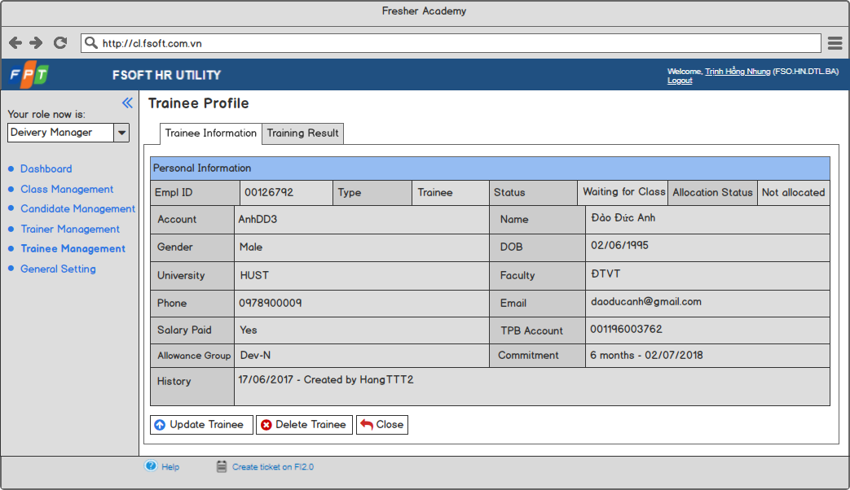

Screen 21: Trainee Profile in view mode – view Trainee Information

### Trainee Profile – Update Trainee Information

This screen is used to update information of an existing trainee.

In order to access this screen, user has to do the following steps:

* Log in successfully.
* Click on “Trainee Management” tab.
* Select a trainee by clicking on Empl ID.
* Click on “Update Trainee” button.

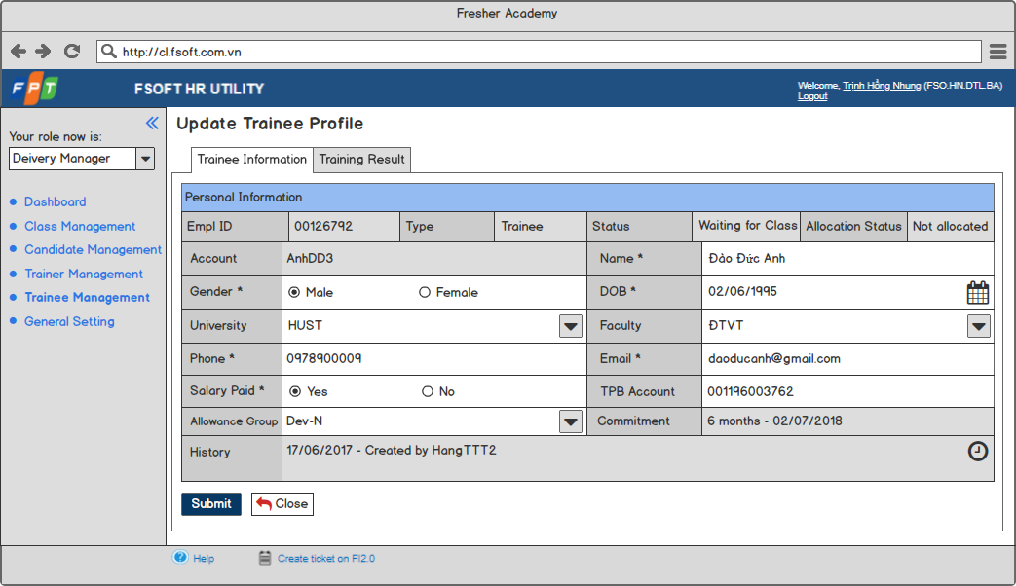

Screen 22: Trainee Profile in edit mode – update Trainee Information

|  |  |  |  |  |  |  |
| --- | --- | --- | --- | --- | --- | --- |
| **#** | **Component** | **Comp. Type** | **Editable** | **Mandatory** | **Default Value** | **Description** |
| 1 | Screen Name | Label | No | N/A. | N/A. | * This field displays text: “Update Trainee Profile” in edit mode. * This field displays text: “Trainee Profile” in view mode. |
| 2 | Tab   * Display components of Trainee. * Display “Trainee Information” tab by default. | | | | | |
| Trainee Personal Information | Tab | No | N/A. | N/A. | This tab displays trainee personal information. |
| Trainee Training Result | Tab | No | N/A. | N/A. | This tab displays trainee training result. |
| 3 | Personal Information Table: Display personal information of a trainee. | | | | | |
| Empl ID | Label | No | N/A. | N/A. | This field is auto-generated by system. |
| Type | Label | No | N/A. | N/A. | This field displays text: “Trainee”. |
| Status | Label | No | N/A. | N/A. | * This field is auto-filled by system upon action of user. * Value list:   + Waiting for Class.   + Enrolled.   + In-progress.   + Deferred.   + Drop-out.   + Waiting for Allocation.   + Allocated. |
| Allocation Status | Label | No | N/A. | N/A. | The value of this field is equal to the value of [Allocation Status] field in allocation table. |
| Account | Label | No | N/A. | N/A. | This field is auto-generated by system as the following rules:   * Get 1st letter in name. * Get 1st letter in surname. * Get 1st letter in middle names. * Combine as the order: Name_Surname_Middlenames_x. * Look-up to [Account] field in database:   + If any matching: x +1, then check duplicate again.   + If no matching: Set the value of [Account] field of current trainee as Name_Surname_Middlenames_x. |
| Name | Text Box | Yes | Yes | N/A. | This field allows user to input trainee full name. |
| Gender | Radio Button | Yes | Yes | Male | * This field allows user to select trainee gender. * Value list:   + Male.   + Female. |
| DOB | Date Time | Yes | Yes | N/A. | * This field allows user to input trainee date of birth. * Date format is DD/MM/YYYY. * User cannot input future date. |
| University | Drop Down List | No | Yes | N/A. | * This drop down list allows user to select trainee university. * This field gets all values from [University Name] field in University entity and includes “Other” value. * Once user selects “Other”, system will display a text box allowing user to input trainee university below with “Input University here” as guideline text as the following:   Snapshot   * After user inputs trainee university and enters, system will display value for this field as the inputted data and create a new item for University entity with the value of [University Name] field as the inputted data. |
| Faculty | Drop Down List | No | Yes | N/A. | * This drop down list allows user to select trainee faculty. * This field gets all values from [Faculty Name] field in Faculty entity and includes “Other” value. * Once user selects “Other”, system will display a text box allowing user to input trainee faculty below with “Input Faculty here” as guideline text as the following:   Snapshot   * After user inputs trainee faculty and enters, system will display value for this field as the inputted data and create a new item for Faculty entity with the value of [Faculty Name] field as the inputted data. |
| Phone | Numeric | Yes | Yes | N/A. | * This field allows user to input trainee phone number. * 10 ≤ inputted value ≤14. |
| Email | Text Box | Yes | Yes | N/A. | * This field allows user to input trainee email address. * This field follows email format. |
| Salary Paid | Radio Button | Yes | Yes | Yes | * This field allows user to select whether trainee is paid salary or not. * Value list:   + Yes.   + No. |
| TPB Account | Numeric | N/A. | No | N/A. | * This field allows user to input trainee TPB account. * This field is enabled only when user selects the value of [Salary Paid] field as “Yes”. |
| Allowance Group | Drop Down List | Yes | No | N/A. | * This field allows user to input trainee allowance group. * This field is enabled only when user selects the value of [Salary Paid] field as “Yes”. * This field gets all value of [Group] field in Allowance Group entity. |
| Commitment | Label | No | N/A. | N/A. | * This field displays commitment of current trainee after joining classes. * This field is auto-filled by system as the format: X – Y. In that:   + X: The total number of [Committed Working Duration] in Class Listing in Training Result tab.   + Y: The latest [Committed Working Start Date] in Class Listing in Training Result tab. |
| History | Label | No | N/A. | N/A. | * This field displays history of current item. * Once user takes any action with current item, system will auto-update this field. |
| 4 | Submit | Button | N/A. | N/A. | N/A. | * This button allows user to create / update a new trainee profile. * Refer to UC 30: Update Trainee Profile for more details of update trainee profile. |
| 5 | Close | Button | N/A. | N/A. | N/A. | This button allows user to discard current action and back to the previous screen. |
| 6 | Update Trainee | Button | N/A. | N/A. | N/A. | * This button allows user to update trainee profile. * Refer to UC 30: Update Trainee Profile for more details. |
| 7 | Delete Trainee | Button | N/A. | N/A. | N/A. | * This button allows user to delete a trainee profile. * Refer to UC 32: Delete Trainee Profile for more details. |

### Trainee Profile – Update Training Result

This screen allows users to update training result of a trainee assigned to a class.

In order to access this screen, user has to do the following steps:

* Log in successfully.
* Click on “Trainee Management” tab.
* Select a Trainee by clicking on Empl ID.
* Click on “Training Result” tab.
* Click on “Update Trainee” button.

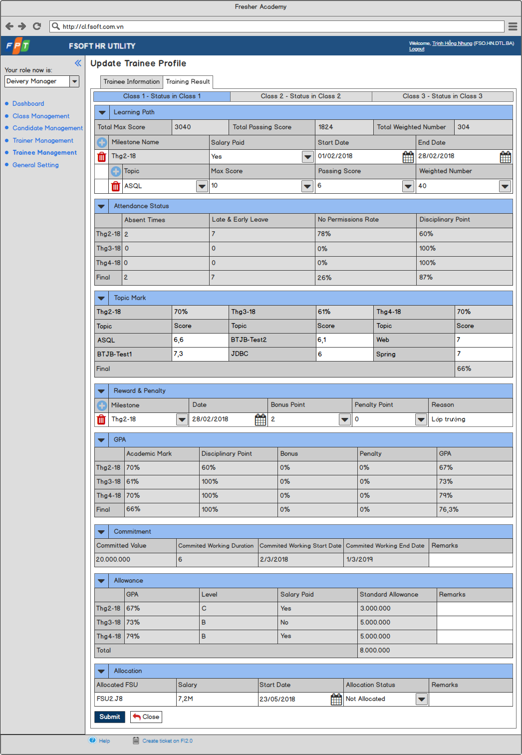

Screen 23: Trainee Profile in edit mode – update Trainee Training Result

### ­Trainee Profile – View Training Result

This screen allows users to view training result of a trainee assigned to a class.

In order to access this screen, user has to do the following steps:

* Log in successfully.
* Click on “Trainee Management” tab.
* Select a Trainee by clicking on Empl ID.
* Click on “Training Result” tab.

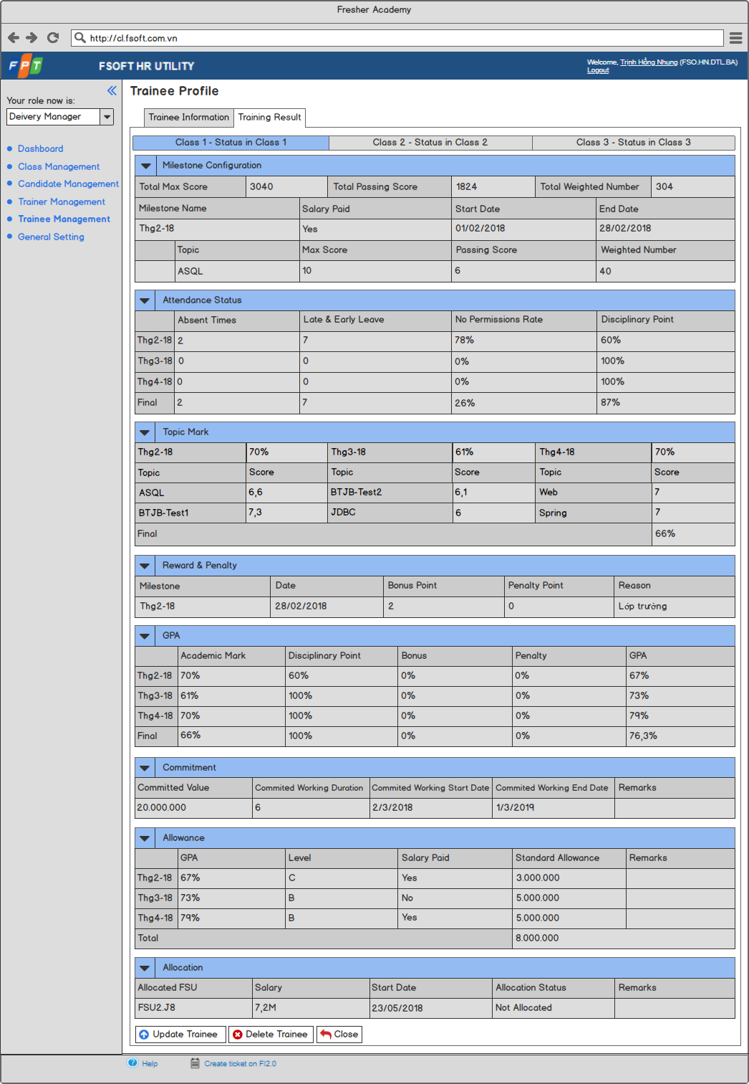

**Screen 24: Trainee Profile in view mode – view Trainee Training Result**

### Trainee Profile – Training Result – Class Listing



Screen 25: Trainee Profile – Class Listing tab

|  |  |  |  |  |  |  |
| --- | --- | --- | --- | --- | --- | --- |
| **#** | **Component** | **Comp. Type** | **Editable** | **Mandatory** | **Default Value** | **Description** |
| 1 | Class Direction | Tab | No | N/A. | N/A. | * This tab displays all classes which current trainee is assigned to. * Tab name format is X – Y. In that:   + X: The value of [Class Name] of all classes which current trainee is assigned to.   + Y: The value of [Status in Class] of current trainee in corresponding class. * Value list:   + Active.   + Drop-out.   + Deferred.   + Passed.   + Failed. * The order of classes from left to right in tab is sorted ascending by the value of [Actual Start Date] field of each class . * Selected class is highlighted in blue. |

### Trainee Profile – Training Result – Milestone Configuration

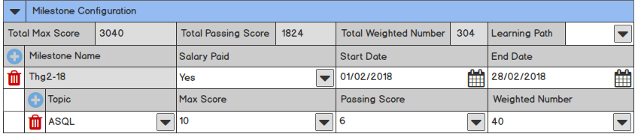

Screen 26: Trainee Profile in edit mode – Training Result – Milestone Configuration table

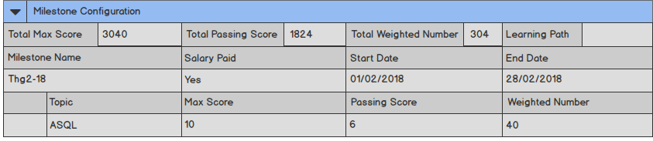

Screen 27: Trainee Profile in view mode – Training Result – Milestone Configuration table

|  |  |  |  |  |  |  |
| --- | --- | --- | --- | --- | --- | --- |
| **#** | **Component** | **Comp. Type** | **Editable** | **Mandatory** | **Default Value** | **Description** |
| 1 | Collapse / Expand | Icon | No | N/A. | N/A. | This icon allows user to collapse / expand Milestone Configuration table. |
| 2 | Table Name | Label | No | N/A. | N/A. | This field displays text: “Milestone Configuration”. |
| 3 | Total Max Score | Label | No | N/A. | N/A. | * This field displays total max score configured in each topic of current class. * This field is auto-calculated by system as the following formula: $$\sum_{k=1}^{n}{\left(Max Score k*Weighted Number k\right)}$$  In that:   * + n: Total number of topics configured   + k: Topic k in n topics configured   + Max Score k: Max score of Topic k   + Weighted Number k: Weighted Number of Topic k * Example:   + Class A has topic 1 and topic 2.     - Topic 1 has max score 1 and weighted number 1.     - Topic 2 has max score 2 and weighted number 2.   + Total max score = (Max score 1 x Weighted number 1) + (Max score 2 x Weighted number 2). |
| 4 | Total Passing Score | Label | No | N/A. | N/A. | * This field displays total passing score configured in each topic of current class. * This field is auto-calculated by system as the following formula: $$\sum_{k=1}^{n}{\left(Passing Score k*Weighted Number k\right)}$$  In that:   * + n: Total number of topics configured   + k: Topic k in n topics configured   + Passing Score k: Passing score of Topic k   + Weighted Number k: Weighted Number of Topic k * Example:   + Class A has topic 1 and topic 2.     - Topic 1 has passing score 1 and weighted number 1.     - Topic 2 has passing score 2 and weighted number 2.   + Total passing score = (Passing score 1 x Weighted number 1) + (Passing score 2 x Weighted number 2). |
| 5 | Total Weighted Number | Label | No | N/A. | N/A. | * This field displays total weighted number configured in each topic of current class. * This field is auto-calculated by system as the following formula: $$\sum_{k=1}^{n}{Weighted Number k}$$  In that:   * + n: Total number of topics configured   + k: Topic k in n topics configured   + Weighted Number k: Weighted Number of Topic k * Example:   + Class A has topic 1 and topic 2.     - Topic 1 has weighted number 1.     - Topic 2 has weighted number 2.   + Total weighted number = Weighted number 1 + Weighted number 2. |
| 6 | Learning Path | Drop Down List | Yes | N/A. | N/A. | * This drop down list allows user to select learning path for trainee. * This fields gets all value from [Learning Path Name] field from [Learning Path] entity. * Once clicking double o the value, system will display detailed information of learning path and allow user to customize. - TBD |
| 7 | Add More Milestone | Icon | No | N/A. | N/A. | * This icon allows user to add more a new milestone. * Once user clicks on this icon, system will add a new row with [Milestone_Name_x] field, [Salary_Paid_x] field, [Start_Date_x] field, [End_Date_x] field, delete milestone icon and topic row including add more topic icon, Topic Column, Max score column, Passing score column, Weighted number column. * “x” starts from “1” and x = x+1. * Once user clicks on this icon, system will add a new row for Attendance Status table, add a new area in Topic Mark table, add a new row for GPA table and add a new row for Allowance table with the row name or area name is equal to generated name. |
| 8 | Delete Milestone | Icon | No | N/A. | N/A. | * This icon allows user to delete a milestone including milestone information and topics configured in deleted milestone. * Once user clicks on this icon, system will remove the row having the same milestone name with removed milestone in Attendance Status table, Topic Mark table, GPA table and Allowance table. |
| 9 | Milestone Name | Label | No | N/A. | N/A | * This field is auto-generated by system after user inputs value for [Start Date] field. * Name format is ThgX-Y. In that:   + X: Month in [Start Date] field.   + Y: 2 last number of year in [Start Date] field. |
| 10 | Salary Paid | Drop Down List | Yes | No | Yes | * This drop down list allows user to select whether trainee is paid salary in current milestone or not. * Value list:   + Yes.   + No. |
| 11 | Start Date | Date Time | Yes | No | N/A. | * This field allows user to input start date of milestone. * Date format is DD/MM/YYYY. * Cannot input past date. |
| 12 | End Date | Date Time | Yes | No | N/A. | * This field allows user to input end date of milestone. * Date format is DD/MM/YYYY. * Cannot input past date. |
| 13 | Add More Topic | Icon | No | N/A. | N/A. | * This icon allows user to add more a new topic in milestone. * Once user clicks on this icon, system will add a new row with [Topic_x] field, [Max_Score_x] field, [Pasing_Score_x] field, [Weighted_Number_x] field and delete topic icon below. * “x” starts from “1” and x = x+1. * Once user clicks on this icon, system will add a new row in corresponding milestone in Topic Mark table with row name is the same as inputted topic name. |
| 14 | Delete Topic | Icon | No | N/A. | N/A. | * This icon allows user to delete a topic. * Once use clicks on this icon, system will remove the row having the row name is the same as removed topic in Topic Mark table. |
| 15 | Topic | Drop Down List | Yes | No | N/A. | * This drop down list allows user to select topic name in milestone. * This field gets all values from [Topic Name] field in Topic entity. |
| 16 | Max Score | Numeric | Yes | No | N/A. | This field allows user to input max score of topic in milestone. |
| 17 | Passing Score | Numeric | Yes | No | N/A. | This field allows user to input passing score of topic in milestone. |
| 18 | Weighted Number | Numeric | Yes | No | N/A. | This field allows user to input weighted number of topic in milestone. |

### Trainee Profile – Training Result – Attendance Status

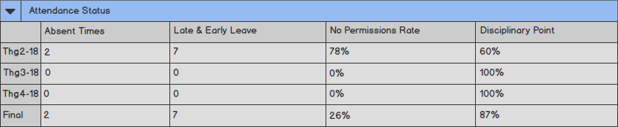

Screen 28: Trainee Profile – Training Result – Attendance Status table

|  |  |  |  |  |  |  |
| --- | --- | --- | --- | --- | --- | --- |
| **#** | **Component** | **Comp. Type** | **Editable** | **Mandatory** | **Default Value** | **Description** |
| 1 | Collapse / Expand | Icon | No | N/A. | N/A. | This icon allows user to collapse / expand attendance status table. |
| 2 | Table Name | Label | No | N/A. | N/A. | This field displays text: “Attendance Status”. |
| 3 | Attendance Status Table:   * Display attendance status of current trainee in current class. * Included Row:   + Each row is a milestone configured in Learning path table.   + Last row is final result.   + Click on row (except for last row), display detailed attendance status of milestone as Screen 29: Trainee Profile – Training Result – Attendance Status of a Milestone in view mode Pop-up. | | | | | |
| Absent Times | Column | N/A. | N/A. | 0 | * For each milestone, the value of this column is calculated by system as the following rules:   + Count the number of “A” and “An” existing in pop-up in corresponding time.   + For each “A” or “An”, the value of [Absent Times] field is increased by 1. * For final result, the value of this column is the number of “A” and “An” counted in all pop-ups. |
| Late & Early Leave | Column | N/A. | N/A. | 0 | * For each milestone, the value of this column is calculated by system as the following rules:   + Count the number of “L” and “Ln” and “E” and “En” existing in pop-up in corresponding time.   + For each “L” or “Ln” or “E” or “En”, the value of [Late & Early Leave] field is increased by 1. * For final result, the value of this column is the number of “L” and “Ln” and “E” and “En” counted in all pop-ups. |
| No Permissions Rate | Column | N/A. | N/A. | 0% | * For each milestone, The value of this column is calculated as the following formula:   X / Y x 100%  In that:   * + X: The number of No permission times calculated by system as the following:     - Count the number of “An” and “Ln” and “En” existing in pop-up in [Milestone_Name_x].     - For each “An” or “Ln” or “En”, the value of X is increased by 1.   + Y: The number of attendance check times calculated by system as (Absent times + Late & Early Leave) in in [Milestone_Name_x]. * For final result, The value of this column is calculated as the following formula:   X / Y x 100%  In that:   * + X: The number of No permission times calculated by system as the following:     - Count the number of “An” and “Ln” and “En” existing in all pop-ups.     - For each “An” or “Ln” or “En”, the value of X is increased by 1.   + Y: The number of attendance check times calculated by system as ([Absent times] + [Late & Early Leave]) in all pop-ups. |
| Disciplinary Point | Column | N/A. | N/A. | 100% | * This column displays disciplinary point of current trainee in corresponding time. * Refer to UC 33: Calculate Disciplinary Point for more details. |

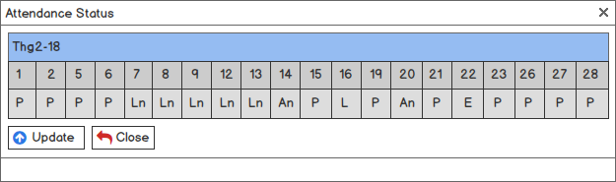

Screen 29: Trainee Profile – Training Result – Attendance Status of a Milestone in view mode

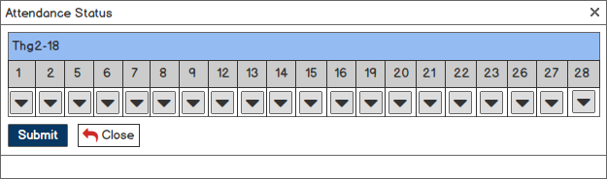

Screen 30: Trainee Profile – Training Result – Attendance Status of a Milestone in edit mode

|  |  |  |  |  |  |  |
| --- | --- | --- | --- | --- | --- | --- |
| **#** | **Component** | **Comp. Type** | **Editable** | **Mandatory** | **Default Value** | **Description** |
| 1 | Pop-up Name | Label | No | N/A. | N/A. | This field displays text: “Attendance Status”. |
| 2 | Attendance Status Table: Display attendance status of current trainee in each lesson of current milestone. | | | | | |
| Table Name | Label | No | N/A. | N/A. | This field displays name of milestone selected. |
| Learning Day | Row | N/A. | N/A. | N/A. | * This row displays learning days in milestone. * The number of value in this row is equal to the number of day which trainee needs to join in milestone except for weekend and holidays. |
| Status_Day | Drop Down List | Yes | No | P | * This drop down list allows user to select attendance status in learning day in current milestone of current trainee in current class. * Value list:   + P (= Present).   + A (= Absent).   + E (= Early Leaving).   + L (= Late Coming).   + An (= Absent with no permission).   + En (= Early Leaving with no permission).   + Ln (= Late Coming with no permission). * Day is equal to date of each learning day in corresponding milestone. |
| 3 | Update | Button | N/A. | N/A. | N/A. | * This button allows user to update attendance status in current milestone of current trainee in current class. * Once user clicks on this button, system will display Screen 32: Trainee Profile in view mode – Training Result – Topic Mark Pop-up. |
| 4 | Close | Button | N/A. | N/A. | N/A. | This button allows user to close pop-up and stay in current screen. |
| 5 | Submit | Button | N/A. | N/A. | N/A. | * This button allows user to save all changes with attendance status in current milestone of current trainee in current class. * Once user clicks on this button, system will update Absent times, Late & early leave, No permissions rate and Disciplinary point of current milestone and final row. |

### Trainee Profile – Training Result – Topic Mark

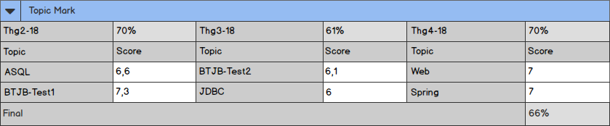

Screen 31: Trainee Profile in edit mode – Training Result – Topic Mark

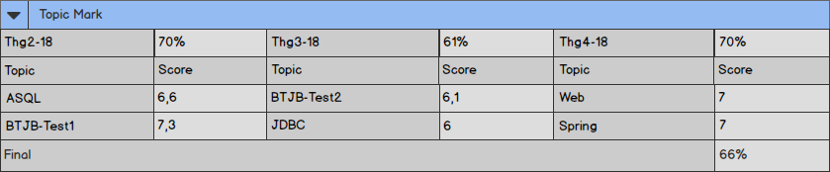

Screen 32: Trainee Profile in view mode – Training Result – Topic Mark

|  |  |  |  |  |  |  |
| --- | --- | --- | --- | --- | --- | --- |
| **#** | **Component** | **Comp. Type** | **Editable** | **Mandatory** | **Default Value** | **Description** |
| 1 | Collapse / Expand | Icon | No | N/A. | N/A. | This icon allows user to collapse / expand topic mark table. |
| 2 | Table Name | Label | No | N/A. | N/A. | This field displays text: “Topic Mark”. |
| 3 | Score in each Topic: Displays score in each topic in each milestone and the average score of current trainee in each milestone. | | | | | |
| Milestone Name | Label | No | N/A. | N/A. | This field displayed milestone name configured in learning path. |
| Average Score of Milestone | Label | No | N/A. | N/A. | * This field displays average score of each milestone. * This field is auto-calculated by system as the following formula: $\frac{\sum_{k=1}^{n}{(Score k*Weighted Number k)}}{\sum_{k=1}^{n}{(Max score k*Weighetd number k)}} x 100\%$ $\frac{\sum_{k=1}^{n}{(Scorek*WeightedNumberk)}}{\sum_{k=1}^{n}{(Maxscorek*Weighetdnumberk)}}x$ d  In that:   * + n: Total number of topics configured in [Milestone_Name_x]   + k: Topic k in n topics configured in [Milestone_Name_x]   + Score k: Score of Topic k in [Milestone_Name_x]   + Max Score k: Max score of Topic k in [Milestone_Name_x]   + Weighted Number k: Weighted Number of Topic k in [Milestone_Name_x] * Example:   + Milestone 1 has topic 1, topic 2.     - Topic 1 has score 1, max score 1 and weighted number 1.     - Topic 2 has score 2, max score 2 and weighted number 2.   + Average score of milestone 1 = {[(Score 1 x Weighted number 1) + (Score 2 x Weighted number 2)] / [(Max score 1 x Weighted number 1) + (Max score 2 x Weighted number 2)]} x 100%. |
| Topic | Column | N/A. | N/A. | N/A. | This column displays topic name of each topic in each milestone. |
| Score | Column | N/A. | N/A. | N/A. | This column displays score of each topic in each milestone. |
| 5 | Final | Row | N/A. | N/A. | N/A. | * This field displays final topic mark of current class. * This field is auto-calculated by system as the following formula: $$\frac{\sum_{k=1}^{n}{(Score k*Weighted Number k)}}{\sum_{k=1}^{n}{(Max score k*Weighetd number k)}} x 100\%$$  In that:   * + n: Total number of topics configured   + k: Topic k in n topics configured   + Score k: Score of Topic k   + Max Score k: Max score of Topic k   + Weighted Number k: Weighted Number of Topic k * Example:   + Class A has milestone 1 and milestone 2.     - Milestone 1 has topic 1 and topic 2.       * Topic 1 has score 1, max score 1 and weighted number 1.       * Topic 2 has score 2, max score 2 and weighted number 2.     - Milestone 2 has topic 3 and topic 4.       * Topic 3 has score 3, max score 3 and weighted number 3.       * Topic 4 has score 4, max score 4 and weighted number 4.   + Final = {[(Score 1 x Weighted number 1) + (Score 2 x Weighted number 2) + (Score 3 x Weighted number 3) + (Score 4 x Weighted number 4)] / [(Max score 1 x Weighted number 1) + (Max score 2 x Weighted number 2) + (Max score 3 x Weighted number 3) + (Max score 4 x Weighted number 4)]} x 100% |

### Trainee Profile – Training Result – Reward & Penalty

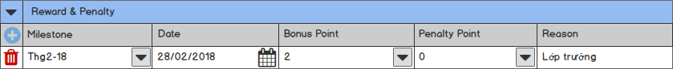

Screen 33: Trainee Profile in edit mode – Training Result – Reward & Penalty

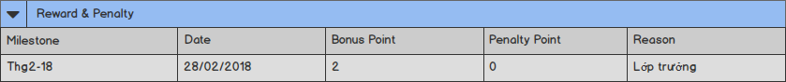

Screen 34: Trainee Profile in view mode – Training Result – Reward & Penalty

|  |  |  |  |  |  |  |
| --- | --- | --- | --- | --- | --- | --- |
| **#** | **Component** | **Comp. Type** | **Editable** | **Mandatory** | **Default Value** | **Description** |
| 1 | Collapse / Expand | Icon | No | N/A. | N/A. | This icon allows user to collapse / expand reward & penalty table. |
| 2 | Table Name | Label | No | N/A. | N/A. | This field displays text: “Reward & Penalty”. |
| 3 | Add More Reward & Penalty | Icon | No | N/A. | N/A. | * This icon allows user to add more a new reward & penalty. * Once user clicks on this icon, system will add a new row with [Milestone_Name_x] field, [Date_x] field, [Bonus_Point_x] field, [Penalty_Point_x] field, [Reason_x] field and delete reward & penalty icon. * “x” starts from 1 and x=x+1. |
| 4 | Milestone | Drop Down List | Yes | No | N/A. | * This drop down list allows user to select milestone on which bonus point / penalty point is recorded. * This field gets all values of [Milestone Name] field configured in learning path table. |
| 5 | Date | Date Time | Yes | No | N/A. | * This field allows user to input date on which bonus point / penalty point is recorded. * Date format is DD/MM/YYYY. * Cannot input future date. |
| 6 | Bonus Point | Numeric | Yes | No | 0 | * This field allows user to input bonus point. * 0 ≤ inputted value ≤ 20. * This field is disabled if inputted value for [Penalty Points] field ≠ “0”. |
| 7 | Penalty Point | Numeric | Yes | No | 0 | * This field allows user to input penalty point. * 0 ≤ inputted value ≤ 20. * This field is disabled if inputted value for [Bonus Points] field ≠ “0”. |
| 8 | Reason | Text Box | Yes | No | N/A. | This field allows user to reason for bonus point / penalty point. |
| 9 | Delete Reward & Penalty | Icon | No | N/A. | N/A. | This icon allows user to delete a reward & penalty. |

### Trainee Profile – Training Result – GPA

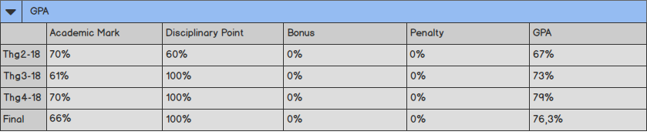

Screen 35: Trainee Profile – Training Result – GPA

|  |  |  |  |  |  |  |
| --- | --- | --- | --- | --- | --- | --- |
| # | Component | Comp. Type | Editable | Mandatory | Default Value | Description |
| 1 | Collapse / Expand | Icon | No | N/A. | N/A. | This icon allows user to collapse / expand GPA table. |
| 2 | Table Name | Label | No | N/A. | N/A. | This field displays text: “GPA”. |
| 3 | GPA Table:   * Display GPA of current trainee. * Included Row:   + Each row is a milestone configured in Learning path table.   + Last row is final result. | | | | | |
| Academic Mark | Column | N/A. | N/A. | N/A. | * This column displays academic mark of current trainee in corresponding time. * The value of this column is equal to average score looked up from topic mark table in corresponding time. |
| Disciplinary Point | Column | N/A. | N/A. | N/A. | * This column displays disciplinary point of current trainee in corresponding time. * The value of this column is equal to disciplinary point column from attendance status table in corresponding time. |
| Bonus | Column | N/A. | N/A. | N/A. | * This column displays bonus point of current trainee in corresponding time. * For each milestone, the value of this column is auto-calculated by system as the following rules:   + In Reward & Penalty table, find all rows having value in milestone column same as milestone name in GPA table.   + Calculate the total bonus point as sum of matched record above.   + Calculate bonus as total bonus points x 10% . * For final result, the value of this column is auto-calculated by system as the following rules:   + In Reward & Penalty table, calculate the summary of values in bonus point column.   + Calculate bonus as total bonus points x 10% . |
| Penalty | Column | N/A. | N/A. | N/A. | * This column displays penalty point of current trainee in corresponding time. * For each milestone, the value of this column is auto-calculated by system as the following rules:   + In Reward & Penalty table, find all rows having value in milestone column same as milestone name in GPA table.   + Calculate the total penalty point as sum of matched record above.   + Calculate penalty as total bonus points x 10% . * For final result, the value of this column is auto-calculated by system as the following rules:   + In Reward & Penalty table, calculate the summary of values in penalty point column.   + Calculate penalty as total bonus points x 10% . |
| GPA | Column | N/A. | N/A. | N/A. | * This column displays GPA of current trainee in corresponding time. * The value of this column is auto-calculated by system in corresponding time as the following formula:   + If [Penalty] = “0%”: GPA = ([Academic mark] x W) + ([Disciplinary point] x X) + ([Bonus] x Y).   + If [Penalty] ≠ “0%”: GPA = ([Academic mark] x W) + ([Disciplinary point] x X) + ([Bonus] x Y) – ([Penalty] x Z).   + In that, W – X – Y – Z is the corresponding weighted number configured when creating class. |

### Trainee Profile – Training Result – Commitment

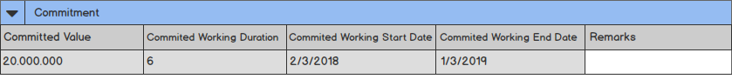

Screen 36: Trainee Profile in edit mode – Training Result – Commitment

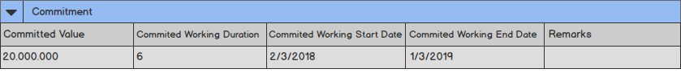

Screen 37: Trainee Profile in view mode – Training Result – Commitment

|  |  |  |  |  |  |  |
| --- | --- | --- | --- | --- | --- | --- |
| **#** | **Component** | **Comp. Type** | **Editable** | **Mandatory** | **Default Value** | **Description** |
| 1 | Collapse / Expand | Icon | No | N/A. | N/A. | This icon allows user to collapse / expand commitment table. |
| 2 | Table Name | Label | No | N/A. | N/A. | This field displays text: “Commitment”. |
| 3 | Committed Value | Label | No | N/A. | N/A. | * This field displays committed value of current trainee with current class. * This field is auto-calculated by system as the following rules:   + Calculate the total number of learning days as the total number of learning days of each milestone configured in learning path.   + Calculate committed value as (Number of learning days / 30) + Total allowance. * Unit is VND. |
| 4 | Committed Working Duration | Label | No | N/A. | N/A. | * This field displays committed working duration of current trainee with current class. * This field is auto-filled by system. * Refer to UC 34: Calculate Committed Working Duration for more details. |
| 5 | Committed Working Start Date | Label | No | N/A. | N/A. | * This field displays committed working start date of current trainee with current class. * This field is auto-filled by system as the value [End Date] field of [Milestone_Name_x] + 1. In that, [Milestone_Name_x] is the milestone having maximum value of x. * Date format is DD/MM/YYYY. |
| 6 | Committed Working End Date | Label | No | N/A. | N/A. | * This field displays committed working end date of current trainee with current class. * This field is auto-filled by system as committed working start date + committed working duration. * Date format is DD/MM/YYYY. |
| 7 | Remarks | Text Box | Yes | N/A. | N/A. | This field allows user to input remarks for commitment of current trainee in current class. |

### Trainee Profile – Training Result – Allowance

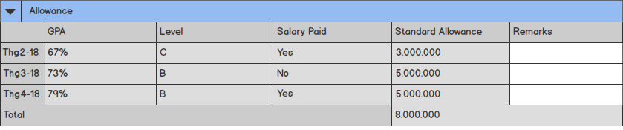

Screen 38: Trainee Profile in edit mode – Training Result – Allowance

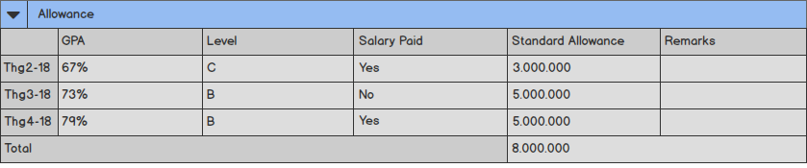

Screen 39: Trainee Profile in view mode – Training Result – Allowance

|  |  |  |  |  |  |  |
| --- | --- | --- | --- | --- | --- | --- |
| **#** | **Component** | **Comp. Type** | **Editable** | **Mandatory** | **Default Value** | **Description** |
| 1 | Collapse / Expand | Icon | No | N/A. | N/A. | This icon allows user to collapse / expand allowance table. |
| 2 | Table Name | Label | No | N/A. | N/A. | This field displays text: “Allowance”. |
| 3 | Allowance Table:   * Display allowance of current trainee in current class. * Included row:   + Each row is a milestone configured in learning path table.   + Last row is total allowance calculated as the total of values in standard allowance column. | | | | | |
| GPA | Column | N/A. | N/A. | N/A. | * This column displays GPA of current trainee in current class. * The value of this column is equal to the value of GPA column in GPA table in corresponding time. |
| Level | Column | N/A. | N/A. | N/A. | * This column displays corresponding level of current trainee in current class in corresponding time. * The value of this column is auto-calculated by system. * Refer to UC 35: Calculate Allowance for more details. |
| Salary Paid | Column | N/A. | N/A. | N/A. | * This column displays whether current trainee is paid salary or not. * The value of this field is equal to the value of [Salary Paid] field in learning path table in corresponding time. |
| Standard Allowance | Column | N/A. | N/A. | N/A. | * This column displays standard allowance of current trainee in current class in corresponding time. * This field is auto-calculated by system. * Refer to UC 35: Calculate Allowance for more details. |
| Remarks | Text Box | Yes | No | N/A. | This field allows user to input remarks for allowance of current trainee in current class. |
| 4 | Allowance | Label | N/A. | N/A. | N/A. | * This is hidden field auto-filled by system. * Refer to UC 35: Calculate Allowance for more details. |
| 5 | Allowance Rate | Label | No | N/A. | N/A. | * This is hidden field auto-filled by system. * Refer to UC 35: Calculate Allowance for more details. |

### Trainee Profile – Training Result – Allocation

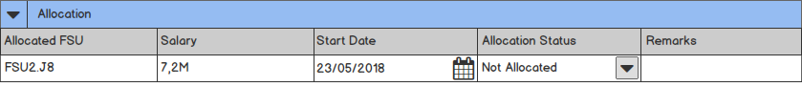

Screen 40: Trainee Profile in edit mode – Training Result – Allocation

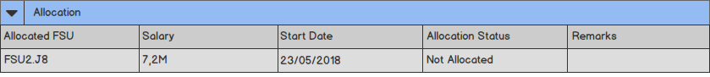

Screen 41: Trainee Profile in view mode – Training Result – Allocation

|  |  |  |  |  |  |  |
| --- | --- | --- | --- | --- | --- | --- |
| **#** | **Component** | **Comp. Type** | **Editable** | **Mandatory** | **Default Value** | **Description** |
| 1 | Collapse / Expand | Icon | No | N/A. | N/A. | This icon allows user to collapse / expand allocation table. |
| 2 | Table Name | Label | No | N/A. | N/A. | This field displays text: “Allocation”. |
| 3 | Allocated FSU | Text Box | Yes | No | N/A. | This field allows user to input FSU name trainee is allocated after training. |
| 4 | Salary | Text Box | Yes | No | N/A. | This field allows user to input salary of current trainee. |
| 5 | Start Date | Date Time | Yes | No | <<Current Date>> | * This field displays actual start date of current trainee. * Date format is DD/MM/YYYY. * Cannot input future date. |
| 6 | Allocation Status | Drop Down List | Yes | No | N/A | * This drop down list allows user to select allocation status of current trainee. * Value list:   + Not allocated.   + Allocated.   + In processing.   + Drop-out. |
| 7 | Remarks | Text Box | Yes | No | N/A. | This field allows user to input remarks for allocation of current trainee in current class. |

# Other Requirements

<Define any other requirements not covered elsewhere in the SRS. This might include database requirements, internationalization requirements, legal requirements, reuse objectives for the project, and so on. Add any new sections that are pertinent to the project.>

# Integration

<Describe external system(s) which integrates with the system>

# Data Migration

<Describe data migration scope and requirements.

In case SRS for data migration in a separated SRS, note down this point: e.g. detailed requirements for Data Migration part will be described on separated SRS. The data migration SRS and the functional SRS will be a couple of documents to fulfil the whole requirements for SSS migration.>

## Migration Scope

This section is to define the scope of data migration. It contains the list of data objects or the specific condition to define the set of data which will be migrated.

## Data Mapping

This section shows the mapping for migrated data. It contains the data properties on the old platform and the corresponding properties on the new platform. Data conversion and data patching rules are also described if any.

# Appendices

## Messages List

|  |  |  |  |
| --- | --- | --- | --- |
| **#** | **Message Code** | **Message** | **Description** |
|  | MSG 1 | Sorry, your username or password is incorrect. Please try again! | * Type = Error Message * Message displays as a warning message with red text above the form when user inputs wrong username or password. |
|  | MSG 2 | Username must be not empty! | * Type = Error Message * Message displays as a warning message with red text above the form when user selects to log in without inputting username. |
|  | MSG 3 | Password must be not empty! | * Type = Error Message * Message displays as a warning message with red text above the form when user selects to log in without inputting password. |
|  | MSG 4 | You must input all required fields! | * Type = Error Message * Message displays as a warning message above the form and borders the inputted area with red line if any field marked with asterisk left blank when user does action such as Submit, etc. |
|  | MSG 5 | Wrong format. | * Type = Error Message * Message displays as a warning message above the form and borders the inputted area with red line if the value of field having format is inputted with wrong format. |
|  | MSG 6 | Please input number only. | * Type = Error Message * Message displays as a warning message above the form and borders the inputted area with red line if the value of field having Component Type as “Numeric” is not number. |
|  | MSG 7 | “Expected Start Date” must not be later than “Expected End Date”. | * Type = Error Message * Message displays as a warning message above the form and borders the inputted area with red line if the value of [Expected End Date] field is earlier than the value of [Expected Start Date] field. |
|  | MSG 8 | Nothing found. | * Type = Error Message * Message displays as a red text above the screen if there is no satisfied result when user select to search. |
|  | MSG 9 | You must start phone number with “0”. | * Type = Error Message * Message displays as a warning message above the form and borders the inputted area with red line if the value of [Phone] field doesn’t start by “0” number. |
|  | MSG 10 | Cannot input future date. | * Type = Error Message * Message displays as a warning message above the form and borders the inputted area with red line if the value of field having description as “Cannot input future date” is in the future. |
|  | MSG 11 | Cannot input past date. | * Type = Error Message * Message displays as a warning message above the form and borders the inputted area with red line if the value of field having description as “Cannot input past date” is in the past. |
|  | MSG 12 | Please select a file. | * Type = Error Message * Message displays as a warning message above the form and borders the inputted area with red line if user does not select any file to upload. |
|  | MSG 13 | This trainee is already existed. | * Type = Error Message. * Message displays as a warning message above the form if the inputted trainee profile is existed in the system. |
|  | MSG 14 | “Start Date” must not be later than “End Date”. | * Type = Error Message * Message displays as a warning message above the form and borders the inputted area with red line if the value of [End Date] field is earlier than the value of [Start Date] field. |
|  | MSG 15 | “Topic” must be unique. | * Type = Error Message. * Message displays as a warning message above the form when user clicks on “Submit” button and the inputted value for [Topic] field is not unique. |
|  | MSG 16 | “Passing Score” must not be greater than “Max Score”. | * Type = Error Message. * Message displays as a warning message above the form and borders the inputted area with red line if the value of [Passing Score] field is greater than the value of [Max Score] field. |
|  | MSG 17 | “Score” must not be greater than “Max Score”. | * Type = Error Message. * Message displays as a warning message above the form and borders the inputted area with red line if the value of [Score] field is greater than the value of [Max Score] field. |
|  | MSG 18 | “Date” must be in “Milestone”. | * Type = Error Message. * Message displays as a warning message above the form and borders the inputted area with red line if the value of [Date] field is not in the selected value of [Milestone] field. |
|  | MSG 19 | 0 ≤ “Bonus Point” ≤ 20. | * Type = Error Message. * Message displays as a warning message above the form and borders the inputted area with red line if the value of [Bonus Point] field is not in the range from 0 to 20. |
|  | MSG 20 | 0 ≤ “Penalty Point” ≤ 20. | * Type = Error Message. * Message displays as a warning message above the form and borders the inputted area with red line if the value of [Penalty Point] field is not in the range from 0 to 20. |
|  | MSG 21 | “Start Date” must be later than “Committed Working Start Date”. | * Type = Error Message. * Message displays as a warning message above the form and borders the inputted area with red line if the value of [Start Date] field is earlier than the value of [Committed Working Start Date] field. |
|  | MSG 22 | Update successfully. | * Type = Notification Message. * Message displays as a green text above the form if all validation rules are passed when user clicks on “Submit” button. |
|  | MSG 23 | Create successfully. | * Type = Notification Message. * Message displays as a green text above the form if all validation rules are passed when user clicks on “Submit” button. |
|  | MSG 24 | 0 ≤ “Phone” ≤ 20 | * Type = Error Message. * Message displays as a red text under the field and borders the inputted area with red line if the value of [Phone] field is not between [10;14] characters. |
|  | MSG 25 | Please choose an excel file to import. | * Type = Error Message. * Message displays as a yellow text above the screen if user upload wrong type of file. |
|  | MSG 26 | Submit successfully. | * Type = Notification Message. * Message displays as a green text above the form when user clicks on “Submit” button in view mode. |
|  | MSG 27 | Approve successfully. | * Type = Notification Message. * Message displays as a green text above the form when user clicks on “Approve Class” button in view mode. |
|  | MSG 28 | Accept successfully. | * Type = Notification Message. * Message displays as a green text above the form when user clicks on “Accept Class” button in view mode. |
|  | MSG 29 | Start successfully. | * Type = Notification Message. * Message displays as a green text above the form when user clicks on “Start Class” button in view mode. |
|  | MSG 30 | Finish successfully. | * Type = Notification Message. * Message displays as a green text above the form when user clicks on “Finish Class” button in view mode. |

## Email Templates

### ET 1: Sending email to Class Admin for assignment

|  |  |
| --- | --- |
| Send to | [Class Admin] |
| CC |  |
| Subject | [FA MANAGEMENT]: The Class [Class Code] is assigned to you. |
| Body | Dear [Class Admin]  The Class [Class Code] - [Class Name] has been assigned for you.  To view the Class details, please click **here**.  Sincerely,  Application Admin.  *Note: This is an auto-generated email, please do not reply.* |

### ET 2: Sending email to Class Admin for change

|  |  |
| --- | --- |
| Send to | [Class Admin] |
| CC |  |
| Subject | [FA MANAGEMENT]: The Class [Class Code] is updated. |
| Body | Dear [Class Admin]  The Class [Class Code] - [Class Name] has been updated.  To view the Class details, please click **here**.  Sincerely,  Application Admin.  *Note: This is an auto-generated email, please do not reply.* |

### ET 3: Sending email to Master Trainer and Trainer for class assignment

|  |  |
| --- | --- |
| Send to | [Master Trainer] [Trainer] |
| CC | [FA Delivery Manager] |
| Subject | [FA MANAGEMENT]: The Class [Class Code] is assigned to you. |
| Body | Dear [Master Trainer] [Trainer]  The Class [Class Code] - [Class Name] has been assigned for you.  To view the Class details, please click **here**.  Sincerely,  Application Admin.  *Note: This is an auto-generated email, please do not reply.* |

### ET 4: Sending email to Class Admin, Master Trainer, Trainer for cancelled Class

|  |  |
| --- | --- |
| Send to | [Class Admin] [Master Trainer] [Trainer] |
| CC |  |
| Subject | [FA MANAGEMENT]: The Class [Class Code] has been cancelled. |
| Body | Dear [Class Admin] [Master Trainer] [Trainer]  The Class [Class Code] - [Class Name] has been cancelled by Delivery Manager.  Sincerely,  Application Admin.  *Note: This is an auto-generated email, please do not reply.* |

### ET 5: Sending email to Delivery Manager for approval

|  |  |
| --- | --- |
| Send to | [Delivery Manager] |
| CC |  |
| Subject | [FA MANAGEMENT]: The Class [Class Code] needs your approval. |
| Body | Dear [FA Manager]  The Class [Class Code] - [Class Name] has been pending for your approval.  To view the Class details, please click **here**.  Sincerely,  Application Admin.  *Note: This is an auto-generated email, please do not reply.* |

### ET 6: Sending email to FA Manager after a Class is approved by Delivery Manager

|  |  |
| --- | --- |
| Send to | [FA Manager] |
| CC |  |
| Subject | [FA MANAGEMENT]: The Class [Class Code] needs your acceptance. |
| Body | Dear [FA Manager]  The Class [Class Code] - [Class Name] has been pending for your acceptance.  To view the Class details, please click **here**.  Sincerely,  Application Admin.  *Note: This is an auto-generated email, please do not reply.* |

### ET 7: Sending email to Class Admin, Master Trainer, Trainer after a class is rejected by Delivery Manager

|  |  |
| --- | --- |
| Send to | [Class Admin] [Master Trainer] [Trainer] |
| CC | [FA. Manager] |
| Subject | [FA MANAGEMENT]: The Class [Class Code] has been rejected. |
| Body | Dear [Class Admin] [Master Trainer] [Trainer]  The Class [Class Code] - [Class Name] has been rejected by Delivery Manager.  To view the Class details, please click **here**.  Sincerely,  Application Admin.  *Note: This is an auto-generated email, please do not reply.* |

### ET 8: Sending email to Delivery Manager, Class Admin, Master Trainer, Trainer after a class is accepted by FA Manager

|  |  |
| --- | --- |
| Send to | [Delivery Manager] [Class Admin] [Master Trainer] [Trainer] |
| CC |  |
| Subject | [FA MANAGEMENT]: The Class [Class Code] has been accepted. |
| Body | Dear [Delivery Manager] [Class Admin] [Master Trainer] [Trainer]  The Class [Class Code] - [Class Name] has been accepted by FA Manager.  To view the Class details, please click **here**.  Sincerely,  Application Admin.  *Note: This is an auto-generated email, please do not reply.* |

### ET 9: Sending email to Delivery Manager, Class Admin, Master Trainer, Trainer after a class is declined by FA Manager

|  |  |
| --- | --- |
| Send to | [Delivery Manager] [Class Admin] [Master Trainer] [Trainer] |
| CC |  |
| Subject | [FA MANAGEMENT]: The Class [Class Code] has been declined. |
| Body | Dear [Delivery Manager] [Class Admin] [Master Trainer] [Trainer]  The Class [Class Code] - [Class Name] has been declined by FA Manager.  To view the Class details, please click **here**.  Sincerely,  Application Admin.  *Note: This is an auto-generated email, please do not reply.* |

### ET 10: Sending email to Delivery Manager, Master Trainer, Trainer, Trainee after a class is started by Class Admin

|  |  |
| --- | --- |
| Send to | [Delivery Manager] [Master Trainer] [Trainer] [Trainee] |
| CC | [FA Manager] |
| Subject | [FA MANAGEMENT]: The Class [Class Code] has been started. |
| Body | Dear [Delivery Manager] [Master Trainer] [Trainer] [Trainee]  The Class [Class Code] - [Class Name] has been started by Class Admin.  To view the Class details, please click **here**.  Sincerely,  Application Admin.  *Note: This is an auto-generated email, please do not reply.* |

### ET 11: Sending email to Delivery Manager after a Class is finished.

|  |  |
| --- | --- |
| Send to | [Delivery Manager] |
| CC | [FA Manager] |
| Subject | [FA MANAGEMENT]: Class Name [Class Code] has been finished. |
| Body | Dear [Delivery Manager]  Class Name [Class Code] has been finished by Class Admin.  To view the Class details, please click **here**.  Sincerely,  Application Admin.  *Note: This is an auto-generated email, please do not reply.* |

### ET 12: Sending email to FA Manager after a Class is closed.

|  |  |
| --- | --- |
| Send to | [FA Manager] |
| CC |  |
| Subject | [FA MANAGEMENT]: Class Name [Class Code] has been closed. |
| Body | Dear [FA Manager]  Class Name [Class Code] has been closed by Delivery Manager.  To view the Class details, please click **here**.  Sincerely,  Application Admin.  *Note: This is an auto-generated email, please do not reply.* |

### ET 13: Sending email to Class Admin after a class is requested by Delivery Manager

|  |  |
| --- | --- |
| Send to | [Class Admin] |
| CC |  |
| Subject | [FA MANAGEMENT]: The Class [Class Code] has been requested for more information. |
| Body | Dear [Class Admin]  The Class [Class Code] - [Class Name] has been requested for more information by Delivery Manager.  To view the Class details, please click **here**.  Sincerely,  Application Admin.  *Note: This is an auto-generated email, please do not reply.* |

### ET 14: Sending email to Candidate and Campus to inform after Candidate is transferred to Campus

|  |  |
| --- | --- |
| Send to | [Candidate] [Campus] |
| CC |  |
| Subject | [FA MANAGEMENT]: Candidate Name [Candidate Code] has been transferred to Campus. |
| Body | Dear [Candidate] [Campus]  Candidate Name [Candidate Code] has been transferred to Campus.  To view the Candidate details, please click **here**.  Sincerely,  Application Admin.  *Note: This is an auto-generated email, please do not reply.* |

### ET 15: Sending email to Candidate and FA to inform after Candidate is transferred to FA

|  |  |
| --- | --- |
| Send to | [Candidate] [FA] |
| CC |  |
| Subject | [FA MANAGEMENT]: Candidate Name [Candidate Code] has been transferred to FA. |
| Body | Dear [Candidate] [FA]  Candidate Name [Candidate Code] has been transferred to FA.  To view the Candidate details, please click **here**.  Sincerely,  Application Admin.  *Note: This is an auto-generated email, please do not reply.* |

### ET 16: Sending email to Candidate and Internship to inform after Candidate is transferred to Internship

|  |  |
| --- | --- |
| Send to | [Candidate] [Internship] |
| CC |  |
| Subject | [FA MANAGEMENT]: Candidate Name [Candidate Code] has been transferred to Internship. |
| Body | Dear [Candidate] [Internship]  Candidate Name [Candidate Code] has been transferred to Internship.  To view the Candidate details, please click **here**.  Sincerely,  Application Admin.  *Note: This is an auto-generated email, please do not reply.* |